Lab 4: Calculate your CO₂ production if you were to drive to school.
(modified from Project LEARN at: www.ucar.edu/learn/1_4_2_20t.htm)
Question: How much CO₂ would you produce if you rode to school in a vehicle?
Procedure: Using Google Earth, measure the distance from your home to the Myron B. Thompson Academy. If you live on a neighbor island, then measure the distance from Oahu’s Aloha Stadium to the Myron B. Thompson Academy. To simplify things, measure a straight line distance and not the actual path you would travel on roads. Realize that the actual distance you would have to drive is likely greater than the straight line distance.
- Download and install Google Earth – Free Version from
http://earth.google.com/download-earth.html.
- Start Google Earth
- Locate your house by typing in your address into the “Fly To” address field in the upper left hand corner and then hit the enter/return button (see Figure 1). The “Fly To” tab should be orange. I’ve typed in a University of Hawaii address as an example (1000 Pope Road …). If you live on a neighbor island, use Aloha Stadium’s address (99-500 Salt Lake Boulevard Honolulu, HI 96818) as your “home”. Go Bows!
Figure 1. Address entry field.
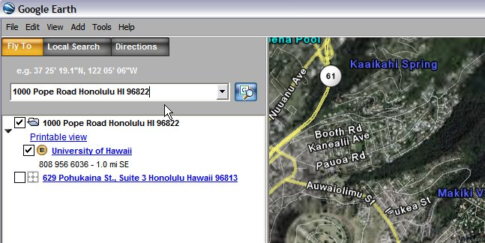
Enter home and school address here

- After zooming in on your house, type in the address of the Myron B. Thompson Academy in the same address entry field that you entered your “home” address and then hit the return button (Figure 1). You can find it at the following URL http://staff.thompsonacademy.org/opencms . The map will shift its focus on the location of the Myron B. Thompson Academy.
- Now, if you can’t see both your “home” location and the Myron B. Thompson Academy, you will need to use the zoom and map moving tools. These are located at the bottom of the Google Map page (see Figure 2). The four white arrows shift the map in those directions. So the arrow pointing to the right moves the map to the right. The plus and minus slider bar on the left zooms in and out of the map. Clicking the plus button zooms in and hitting the minus button zooms out.
Figure 2. Google zoom and map moving tools located at the bottom of the page.

Zoom in and out slider bar
Map moving arrows
- Now, after you can see both your “home” and the Myron B. Thompson Academy, you need to measure the distance between the two. To do this, you are going to use the “Measure” tool under “Tools” menu tab at the top of the page (see Figure 3). Click the “Measure” option.

Figure 3. Google measuring tool.
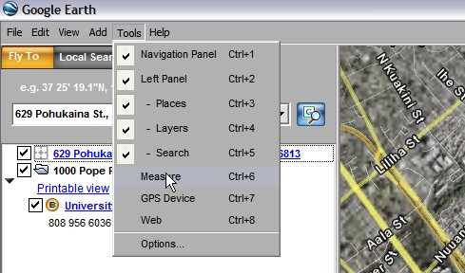
- After clicking the “Measure” option, you will get the following grey window (Figure 4). Make sure you have “Miles” selected as your length. Also, make sure you have clicked the box “Disable Mouse Navigation”.
Figure 4. Grey measuring tool window.
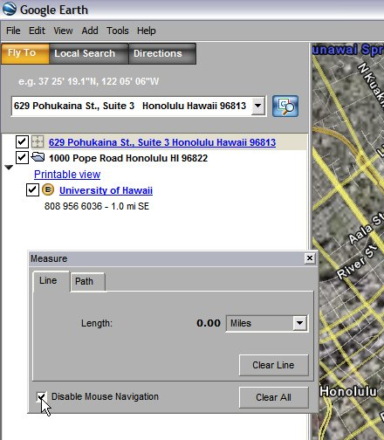

- Now, you are ready to measure the distance between your “home” and the Myron B. Thompson Academy (see Figure 5). To do so,
  - put your mouse pointer over your “home” location on the map (your mouse pointer should be crosshairs now).
  - Click once on your home
  - Now move the pointer to the school. A white line should be created by doing so between the “home location” and the mouse pointer.
  - Once over the school location, click once.
  - There should be a white line between your “home” and the school.
  - Look at the “Measure” box and record the distance in miles (see yellow circle).
Figure 5. Line drawn using measuring tool (thin white line at bottom of image) and resultant length given in miles in the grey box (see yellow circle)
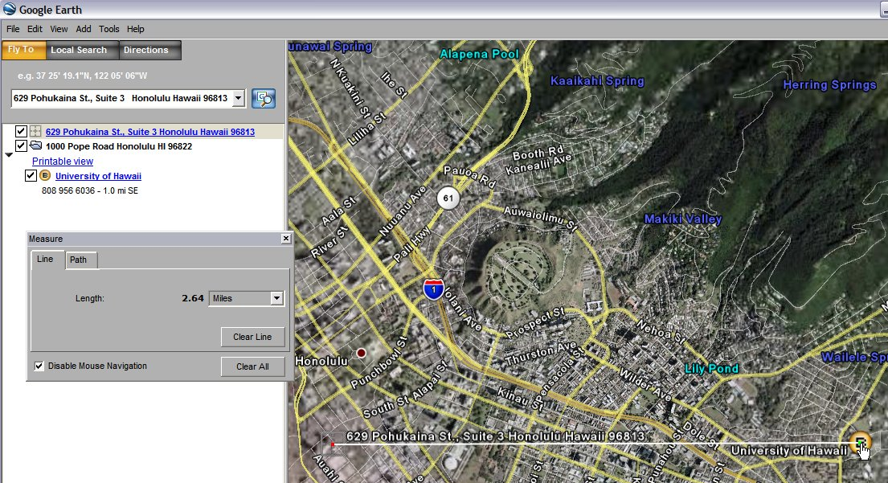
Line drawn using measure tool
Distance measured

- Now, calculate the contribution of CO₂ due to vehicle use:
  - Identify the type of vehicle you would use to travel to school based on the types listed in the table below.
  - Calculate the amount of gas used weekly if they rode to and from school everyday in a private car. Determine which private vehicle you use from Table 1. Then:
    - Add up the total number of miles for 10 round trips to school (remember, each time you are dropped off at school, the driver has to drive home, so there are 2 round trips a day)
    - Divide the total miles per week by the miles per gallon (see Table 1 below ) to determine the gallons of gas burned.
    - Multiply the CO₂ released per gallon. Assume that a gallon of gas used produces 20 pounds of CO₂.
    - Example: If you live 4 miles from school, your car travels 16 miles per day to drop you off and pick you up, or 80 miles per week. At that mileage, a full-size car will burn 5 gallons of gas per week. Five gallons of gas will produce 100 pounds of CO₂ every week.
    - Use Table 2 to report your data.
Table 1. Assumed mileage and pounds CO₂ per gallon created.
Vehicle | MPG | Pounds CO₂ per gallon*
Compact car | 24 | 20
Full-size car | 16 | 20
Truck/Van | 13 | 20
Bus | 8 | 20

    - we’ll assume that trucks/vans and buses created the same pounds CO₂ per gallon fuel burned, but it is slightly different.

Table 2. Answer table.
Vehicle | Miles  Per  Gallon  (MPG) | Daily  Total Miles | Week  Total Miles | Pounds CO₂  per gallon | Weekly  Total Pounds  CO₂ Burned
 |  |  |  | 20
  - Post your weekly total pounds CO₂ burned on the discussion board. Once everyone has posted their result, calculate the class total.
Table 3. Class Total CO₂ Burned.
Class total CO₂ Burned
  - Now calculate how much CO₂ would be produced if the total number of students in the class rode the bus from your “home” to the school. Assume that the bus can hold all the students. Also calculate the total pounds CO₂ per student. Is this total lower than your individual total? Use Table 4 to enter your answers.
Table 4. How much CO₂ per student if every student rode the bus from your “home” location.
Vehicle | Miles  Per  Gallon  (MPG) | Daily  Total Miles | Weekly  Total Miles | Pounds CO₂  per gallon | Weekly  Total Pounds  CO₂ Burned | Weekly Total Pounds CO₂ per student
Bus | 8 |  |  | 20

  - D
- Now, compare the difference between the class total determined by individual transportation (Table 3) and the class total when everyone rides the bus from your home (Table 4). Compare the results. How much difference is there? Answer here

Writing assignment
Although the above exercise is just a rough estimate, would you encourage students to ride a bus to school versus driving their own cars? If so, why? If not, why? Give five ideas of how you could encourage students to ride a bus instead of in a personal vehicle to school.
Answer here:

