Lab 2: Tree Ring Laboratory
(modified from UCAR http://www.ucar.edu/learn/1_2_2_11s.htm)
Overview: Trees contain some of nature's most accurate evidence of the past. Their growth layers, appearing as rings in the cross section of the tree trunk, record evidence of floods, droughts, insect attacks, lightning strikes, and even earthquakes.
Each year, a tree grows. The new growth is called a tree ring. How much the tree grows depends on such things as how much water was available. Because the amount of water available to the tree varies from year to year, scientists can use tree-ring patterns to reconstruct regional patterns of drought and climatic change. This field of study, known as dendrochronology, was begun in the early 1900s by an American astronomer named Andrew Ellicott Douglass.
By counting the rings of a tree, we can pretty accurately determine the age and health of the tree and the growing season of each year. In general, the wider the ring the wetter the year.
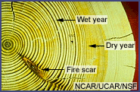
Modern dendrochronologists seldom cut down a tree to analyze its rings. Instead, core samples are extracted using a borer that's screwed into the tree and pulled out, bringing with it a straw-size sample of wood about 4 millimeters in diameter. The hole in the tree is then sealed to prevent disease.
In this activity, you will use the below strip samples below that simulate tree-ring cores. The four strip samples (Sample A, B, C, and D) are examples of tree cores. Each vertical bar or ring represents a year. Generally speaking, the width of each bar (each bar/ring represents a year) gives us an idea if there was a lot (wide bar) or little (narrow bar). The pith represents the core of the tree and the bark represents the outside of the tree.

Sample A – Kaneohe Pine
Pith Bark

Sample B – Mauna Wili Ohia
Pith Bark

Sample C – Kailua Pine
Pith Bark

Sample D – Manoa Pine
Pith Bark

Procedure
- You need to determine the ages of each of the trees.
  - Count the rings carefully, remembering that each ring represents one year of growth.
  - The pith (central layer) and bark are not counted in determining the age of a sample.
  - The youngest ring is closest to the bark and the oldest ring is closest to the pith.
- Record the tree ages in the data table below.
Sample | Age of Tree | Year Cut or Cored | Year Growth Began
1 |  | 1993
2
3
4
- Sample 1 was cored in 1993, meaning that the outer ring grew that year. How can you tell what year Sample 1 started growing? Figure that out and record the year in the data table for Sample 1.
- Samples 2, 3, and 4 were cut down before the tree ring core was taken − but we don't know exactly when. How can we figure out both the year they were cut and the year they started growing from the tree ring cores? To do this, look at all four cores. You should see that there are patterns in the rings − some are wide and some are narrow.
  - Wide rings indicate that the tree was growing fast that year, probably because the weather was good
  - Narrow rings indicate slow growth, probably linked to regional drought or cold temperatures
All of these trees were growing in the same general climate, so if they were alive at the same time, they should show the same ring patterns. Can you match any ring patterns between cores? Once you have found some pattern matches, line up the cores so that the patterns overlap. You will need to print the samples, cut them out individually, and then line them up (see Figure 1 below).
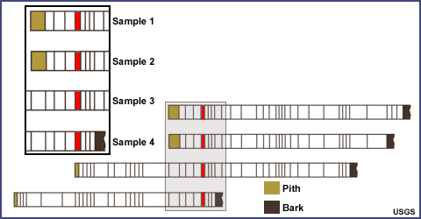
Figure 1: Example of pattern matching in the tree cores.
(Note that your patterns won't look like this.)
- Once the cores are lined up, here's how you can determine their ages. You know that 1992 is the last ring on Sample 1. Count backward until you get to the ring that matches on another core. That ring was produced in the same year on both cores. Now you can count backward on this core until you reach the first matching ring on the next core. Those rings were produced in the same year as well. Repeat for the last core. Now simply count backward to the end of the cores and you have the year the trees began to grow. Record the data in the data table.
Observations and Questions
Type in your answers after each question. Send this entire file (including the table you filled out above) to the instructor.
- Which tree ring represents your birth year?
- What kind of growing season (good or bad) existed that year in Manoa, Mauna Wili, Kailua, and Kaneohe? How can you tell?
- If poor tree growth was mainly caused by drought, which years were probably drought years? How can you tell?
- Did Hawaii have more years of drought or plentiful rainfall? Does it vary depending on location?

