Maps and cross sections (i)

I Main Topics
A Three point problems
B Rule of vees
C Map interpretation and cross sections
II Three point problems (see handout)
A Three points define a plane
B The line of strike is given by the bearing of a horizontal line in a plane; a horizontal line connects points of equal elevation.
C The angle of dip is given by looking parallel to strike in a cross section drawn perpendicular to the line of strike.
III Rule of vees
Although not usually phrased this way, this is really a three-point problem. Find a line of strike for the feature of interest by finding two points on the feature at equal elevation (this follows from the definition of strike). Points on opposite sides of a stream, where the feature intersects a particular contour line, are a good choice of points. Note the elevation of this line of strike. Then find a third point at a known elevation on the feature that is off the line of strike (e.g., where the feature intersects the stream bed). The positions and elevations of these three points allow the direction and amount of dip to be determined.
IV Map interpretation and cross sections
A Project structural information on planes (e.g., location of bedding contacts) along lines of strike onto the plane of the cross section
B The elevation of the structural information is plotted at the appropriate elevation
C Strike view cross sections differ from arbitrarily chosen cross sections in that the lines of projection are straight in the strike view cross sections but are dog-legged (bent) in the arbitrarily chosen cross sections.
D Cross sections of the geologic structure only will not show topography, just the geologic structure
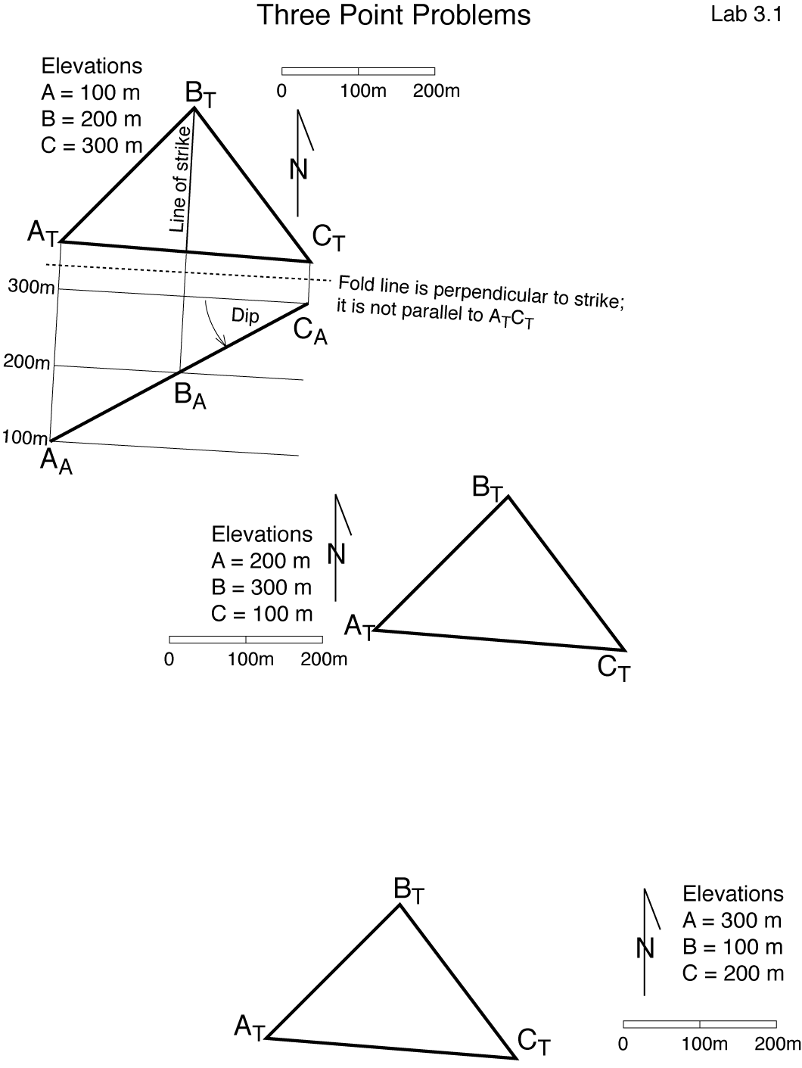
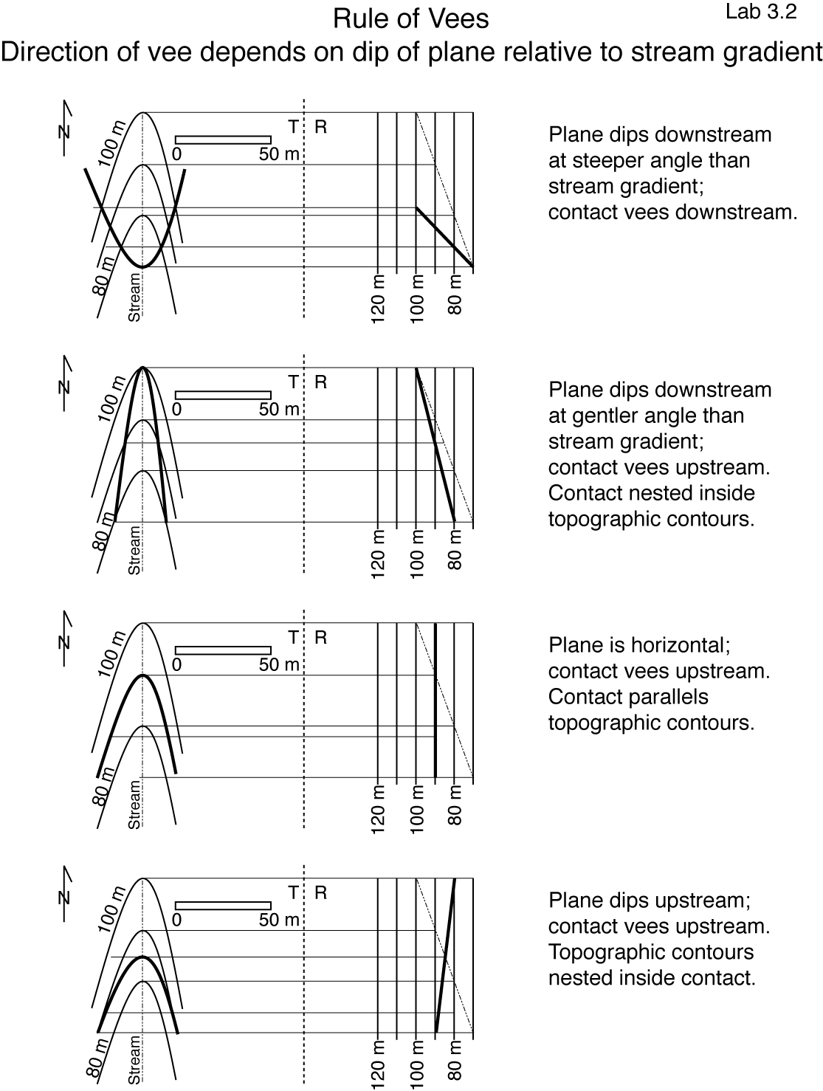
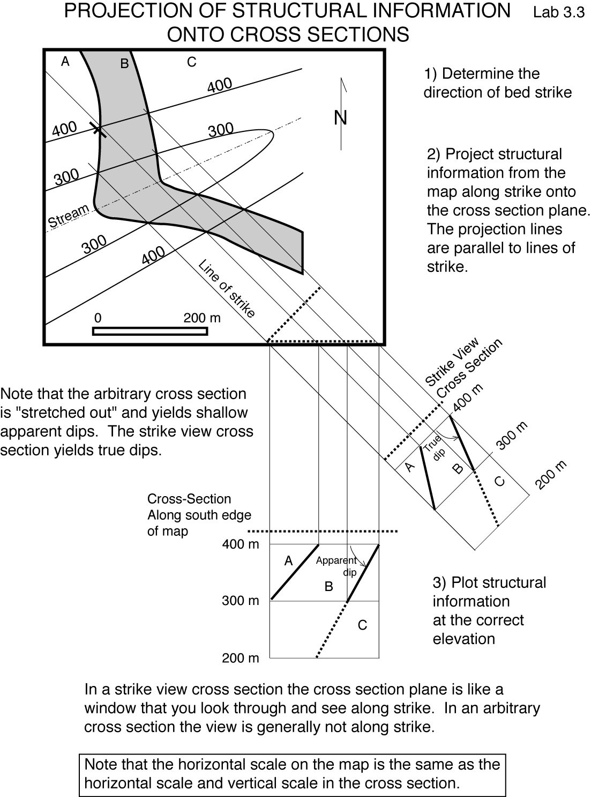
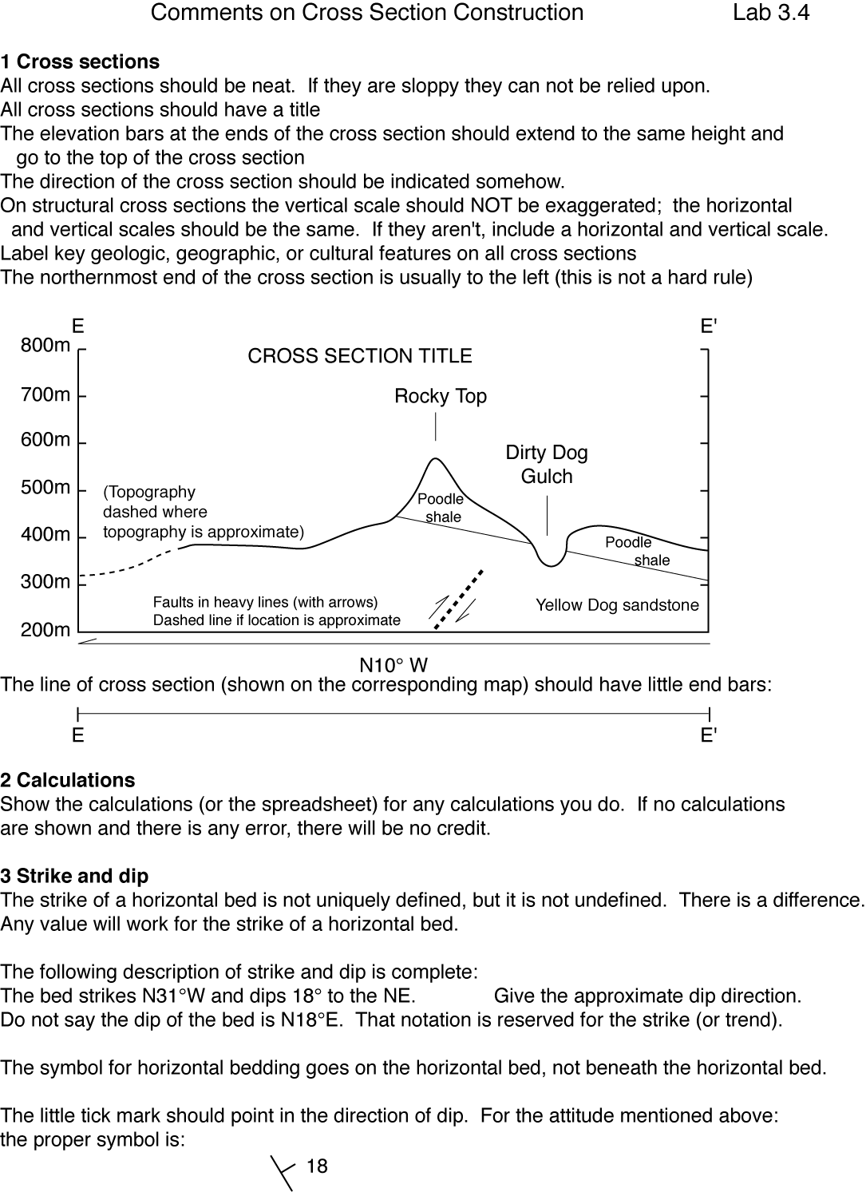
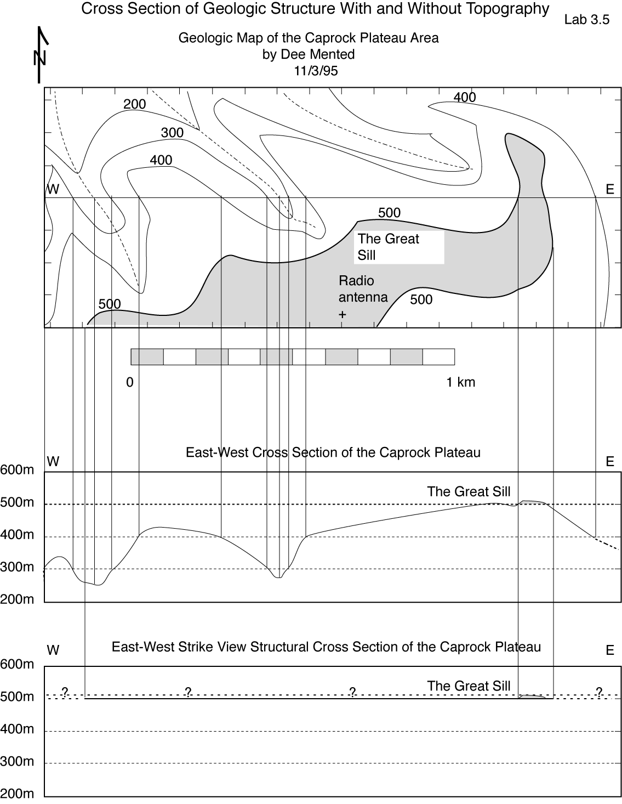
Exercise 1 (27 points total)
Three points with the following coordinates lie on a planar bed:
A: 0m N, 400m E, 400m elev; B: 0m N, 0m E, 300m elev;
C: 300m N, 0m E, 500m elev. You are asked to find the orientation of the plane as in the example of 3.1.
1a Plot and label the points on the attached map; the axes cross at the coordinate origin. (3)
1b Draw and label a line of strike through point A for the bed on the map (2)
1c Determine to the nearest 45° (i.e., N, NE, E, SE, S, SW, W, or NW) the direction of dip and write it here: direction of dip = _____________.(1)
1d Measure the strike of the bed (use the right-hand rule) and write it here:
strike = _______(2)
1e Draw a dashed cross section line (fold line) through point E that is perpendicular to strike and that divides the top view of the map from auxiliary view A. Label the elevation of this line "600m" in auxiliary view A. (2)
1f Project points A, B, and C onto the auxiliary cross section view, then measure and label the dip of the plane and write it here (include the dip direction):
dip = _________________(4)
1g Measure the horizontal component of the shortest distance (H) on the map between the line of strike and point B (use the map scale) and write it here: distance = _______________(2)
1h Label on the cross section (A) view the vertical distance (V) and horizontal distance (H) between your line of strike and point B, and label on the top view the horizontal distance (H); this is a total of three labels (3)
1i Write the mathematical expression relating the dip of the plane to H and V here: dip = ___________________________(2)
1j Based on the mathematical expression relating the dip of the plane to H and V, calculate the dip of the plane and write it here: dip = _________________(2)
1k The trend of the pole to the bed is: _________________(2)
1l The plunge of the pole to the bed is: _________________(2)
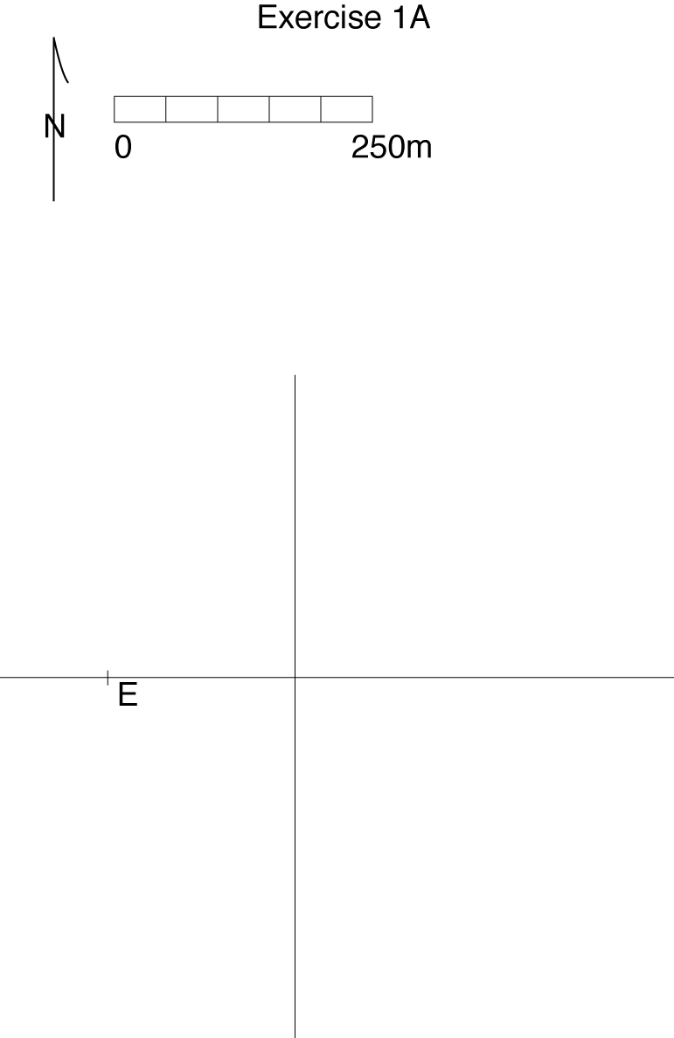
Exercise 2 (26 points total)
The points on the map of Exercise 2 lie on a planar bed, and the labeled elevations for the points are in meters.
2a Determine the elevations of five structure contours for the bed, with the highest and lowest contours passing through the points with the highest and lowest elevations, respectively; the contour interval should be uniform. The elevations of the points are given in meters. List the contour elevations below. (5)
Contour 1 _______________ Contour 2 _______________
Contour 3 _______________ Contour 4 _______________
Contour 5 _______________
2b The strike of the bed is (use the right-hand rule): strike = _____(2)
2c On the map, draw and label five structure contours for the bed, with the highest and lowest contours passing through the points with the highest and lowest elevations, respectively; the contour interval should be uniform. (5)
2d Determine to the nearest 45° (i.e., N, NE, E, SE, S, SW, W, or NW) the direction of dip and write it here: direction of dip = __________.(1)
2e Draw a cross section perpendicular to the lines of strike, and by projecting at least 4 points onto the cross section, determine the dip of the plane and general dip direction, and write them here: dip = ______________(5)
2f Measure the shortest horizontal distance (on the map) between the high and low structure contours and write it here: distance = ____________(2)
2g Based on the vertical and horizontal distances between your high and low structure contours, calculate the dip of the plane and write it here: dip = _______________(2)
2h The trend of the pole to the bed is: _______________(2)
2i The plunge of the pole to the bed is: ______________(2)

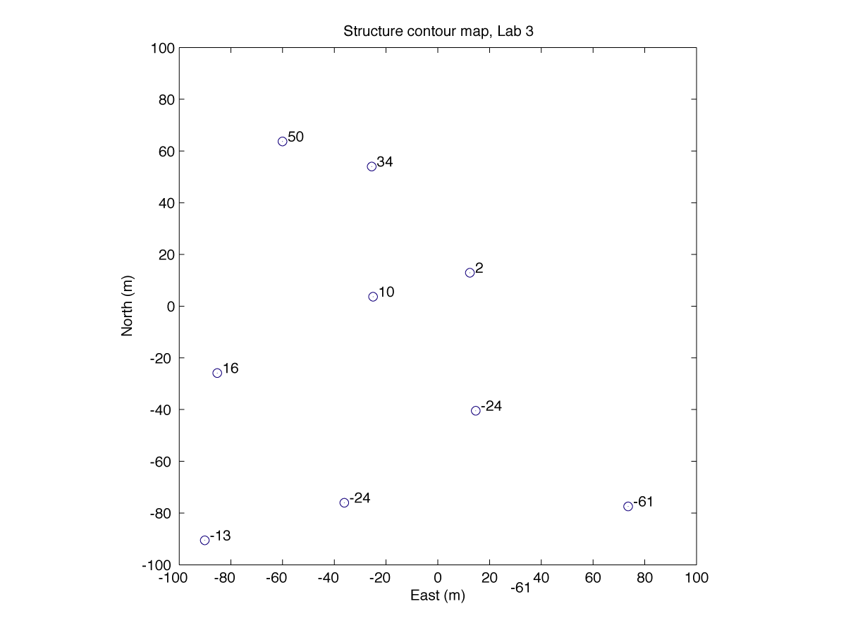

Exercise 3 (See attached geologic map of the Caprock Plateau; elevations are in meters) (59 points total)
Three planar dikes labeled A, B, and C cut the Paleocene Puddingstone and the Cretaceous Chalk.
3a Determine the strike and dip (and dip direction) of these dikes as well as the attitude of the contact between the Paleocene Puddingstone and the Cretaceous chalk (this contact is labeled D).
 | A | B | C | D
Strike (4x4)
Dip (4x4)

3b Draw four attitude symbols on the map that show the strike and dip of each feature (draw one for each feature). Locate the symbols where you collected information to determine the strike and dip of the features. (4x3)
3c Draw a line through the radio tower showing the orientation of a vertical cross section plane that is perpendicular to the strike of dike A. Label the end points E and E' (3)
3d Draw cross section E-E' showing the topography and dike A (10)
3e Does this cross section plane allow you to see the true dip of dike A? Explain briefly.
_________________________________________________________________
_________________________________________________________________
____________________________________________________________(2)
