GG 450L: Geophysical Methods Lab
LAB 6:
How to Use Seismic Equipment & Pick Travel Times
Due Tuesday 6 April

This lab will demonstrate the use of a refraction seismograph by conducting a test survey on campus. We will use the SmartSeis Seismograph system in which a sledge-hammer is used to generate seismic waves.

1) Sketch the geophone layout. Include channel number, distance between geophones, and shot point locations.
Please take turns operating the seismograph and using the hammer. We will save data from two shots in this lab, a forward shot (near to geophone #1) and a reverse shot (near geophone #12). Once the data is collected and you are familiar with operating the seismograph return to POST 733 to begin the data analysis.
Copy the three data files onto your home (Z) drive on bambam. These files should have .dat extensions. We will use the program “Pickwin95” to pick the first arrival times at each geophone. This program is on a memory stick to be provided in class. First, copy this folder into your Z drive.

In the computer lab you will view the data and pick travel times.
2. Use “Pikwin95.exe” to pick the first arrivals for the two data files (see instructions below). Make a printout of your picks for each shot point from Pikwin95. Save your picks to disk.
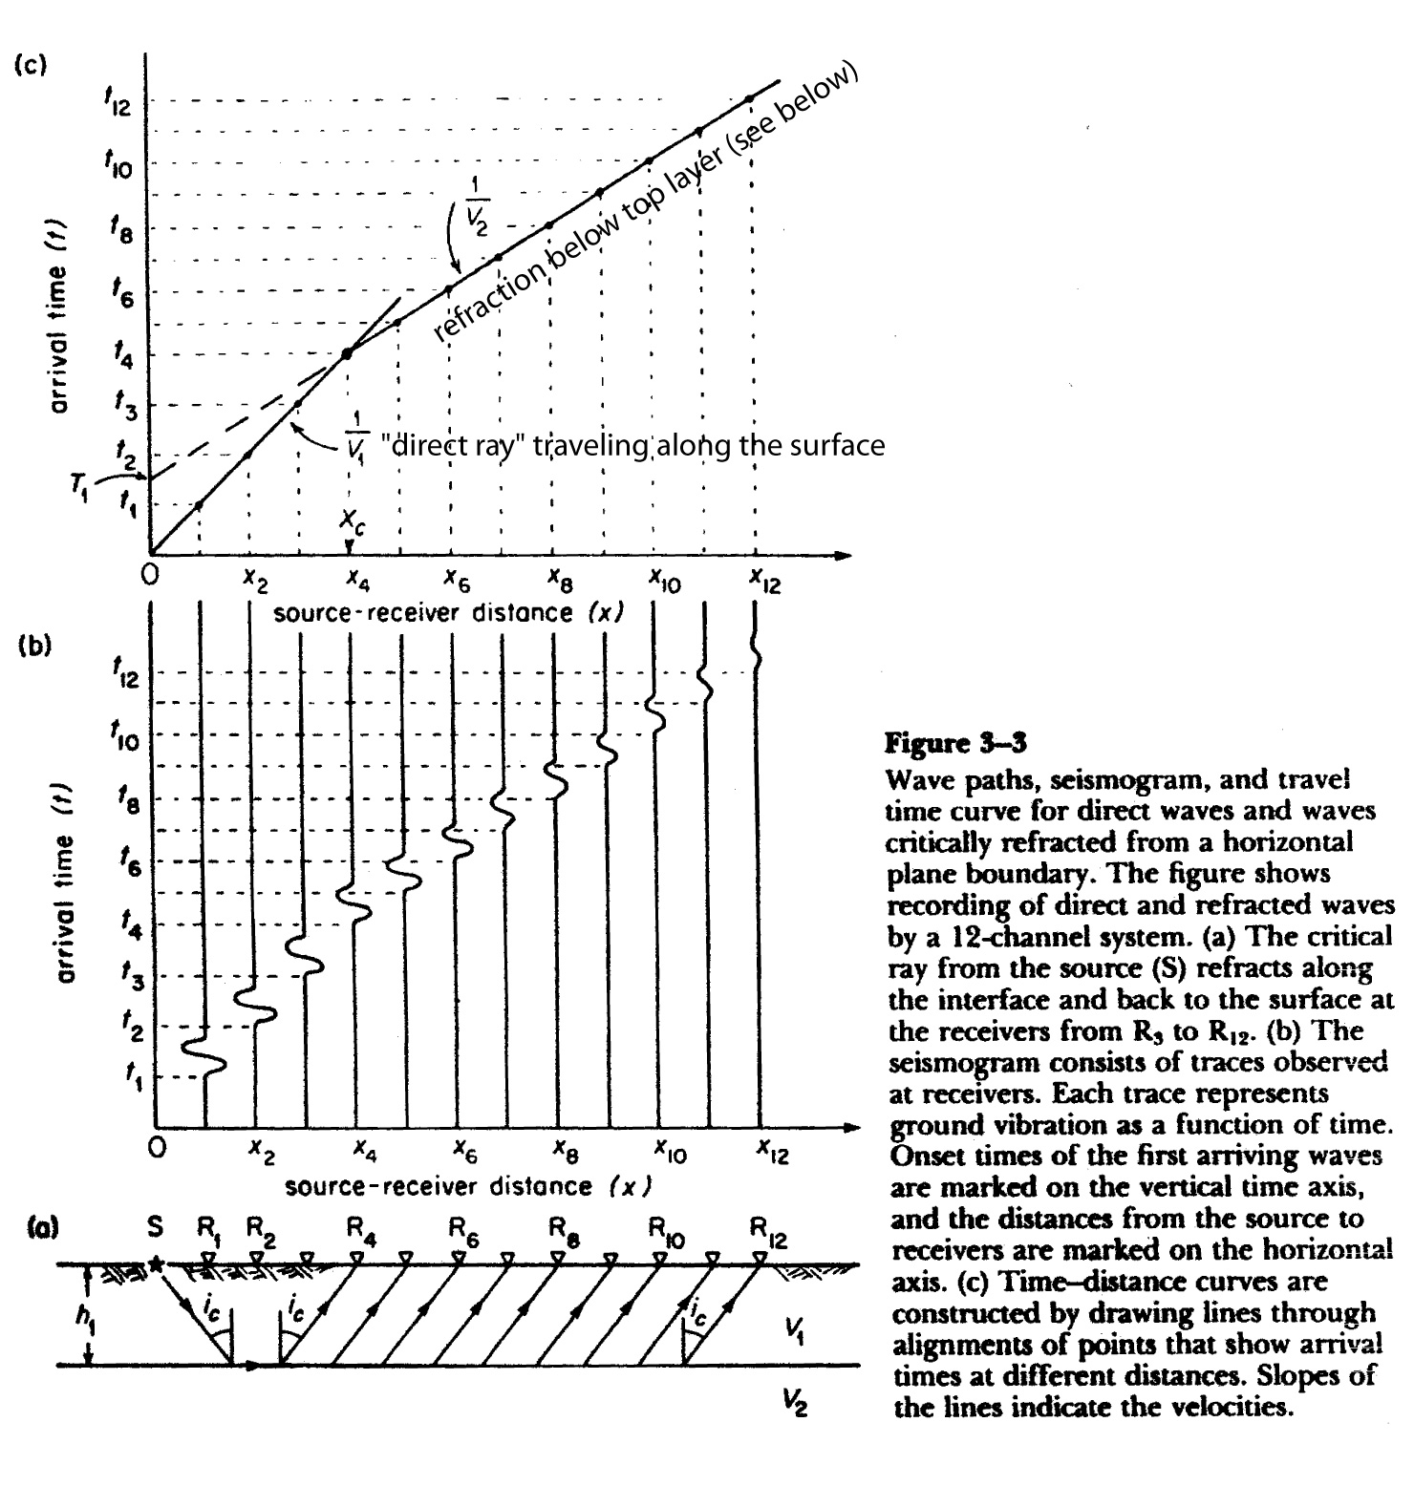
- Use Matlab to make a plot of travel time t_{R} vs. distance x from the “.vs” files generated by Pickwin95. You will need to remove the first three and last three lines of the “.vs” file before loading the file into Matlab. Load them into Matlab using “load” as you did before in prior labs and set up arrays of x and t_{R}. Now generate your plot. I recommend using symbols like “*” or circles to mark you picks on your plot. Use this plot to determine the average velocity of the upper layer, V₁. To do this you should determine the slope of the line that bests fits your picks for the nearest distances (about the nearest half) of the geophone array (see above figure). Rather than using polyfit I suggest using a pencil and paper since you will have to fit different parts of the record.
- A second velocity layer should be apparent if you recognize first-arrivals at larger shot-receivers distances x but that have a different slope than the line you fit above to the nearer receivers (see figure above). Fit a line (travel time t_{R} versus x) to the refractions from this second layer. The velocity of the second layer V₂ is the inverse of the slope of this line and the intercept with the time axis is T₁. From Equations 3-25 to 3-28 of the text.
.
From this information, determine the thickness of the upper layer by using Eq. 3-30 of the text.

SeisImager Instructions

SeisImager comes in two parts – Pickwin95, and Plotrefa. Pickwin95 is the program you will use to load in the .dat files taken in the filed, pick first-breaks, and store the results.
1) double click on Pickwin95: after a few seconds, a window comes up that says “No waveform data”
2) go to the “file” menu: Open SEG2 file
3) go to the folder containing the data and double click on the file you are interested in…the data will appear in the window….look at it and check to see that the shot location and geophones are at the locations they should be in
4) check and change any bad header information (shot location, geophone location, etc.) by going to the “Edit” menu: show/edit source/receiver locations, etc….a table of parameters is displayed…be sure the numbers under Rec. Distance and “Source” are the expected values of feet/meters
5) hit the “OK” button when all numbers are correct…the program will return to the travel time window
6) if any of the traces have poor data or no data, you can click on the white arrow, and then on the trace to turn it red and then hit “delete” to make it go away
7) now pick the first arrivals: go to the menu: “Pick first arrivals”: and click Pick first breaks…vertical red lines appear where the program thinks the signal starts…while it’s pretty good, it often takes some fudging
8) use the red up and down arrows to the left side of the menu bar at the top to adjust the trace sizes until you can see why the program picked the arrivals where it did…you can move the pick by just clicking where you think it should be (often based on the surrounding traces)
9) once you are happy with the picks, click on the red start in the menu bar, and a line will connect all your picks
10) if you’re still happy with the picks, you need to store your results…File: Save first break pick file
11) you will use this file to load into Matlab and plot your first arrivals for analysis.

