Intersections of Planes

I Main Topics
A Equation of a plane
B Pole to a plane using cross-products
C Intersection of two planes in a line
D Intersection of three planes in a point (solution of simultaneous linear equations)
II Equation for plane P1: n•V = d
A Here d is the distance from a known reference point to plane P1 as measured in the direction of a unit vector n that is normal to the plane. The distance d is positive if the unit normal points from the reference point towards the plane; the distance d is negative if the unit normal points from the plane towards the reference point.
B Solution for n = αi + βj + γk = <α, β, γ >
1 α = cosφcosθ, β = cosφsinθ, γ = sinφ if x=north, y=east, z=down
2 α = cosφsinθ, β = cosφcosθ, γ = -sinφ if x=east, y=north, z=up
where θ is the pole trend and φ is the pole plunge
3 Matlab: [alpha,beta,gamma] = sph2cart(trend, plunge,1) Trend and plunge must be in radians.
4 Matlab: [trend, plunge,R] = sph2cart(alpha,beta,gamma) Good for z = down; trend and plunge must be in radians.
C Solution for V
This is just the x,y,z position of a point (any point) on the plane
D Solution for d
1 d = αx + βy + γz (Normal form for equation of a plane)
2 d = dot(n,v) (See Matlab help page)
III Pole to a plane using cross-products
Consider three non-colinear points that lie in a plane: A (xA,yA,zA), B (xB,yB,zB), and C (xC,yC,zC).
A (A-C)x(B-C) is normal to the plane
B (A-C)x(B-C)/|(A-C)x(B-C)| = n, a unit normal to the plane.
IV Intersection of two planes in a line
A Two planes P1 and P2 intersect in a line. The equations of those two planes define the line.
B The direction of intersection is along the vector that is the cross product of a vector normal to plane P1 and a vector normal to plane P2.

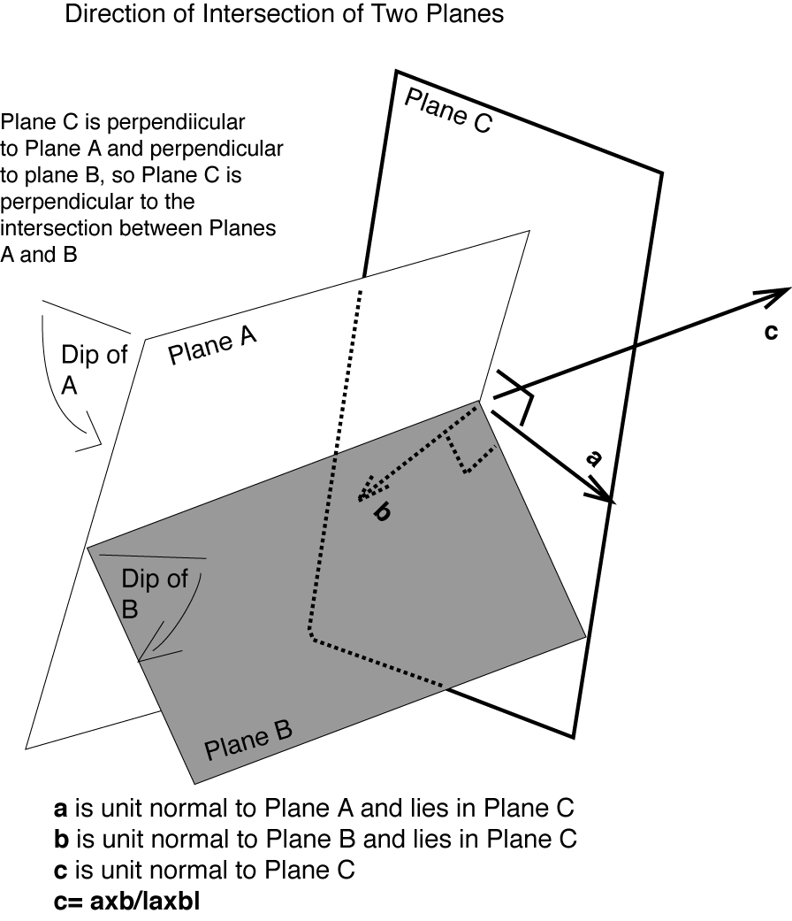
C Apparent dip
- How the plane of interest appears to dip as seen through the “window” of a cross section plane.
- Plunge of the line of intersection between a vertical cross section plane and the plane of interest.
- A vector along the apparent dip is given by the cross product of a vector normal to the plane of interest and a vector normal to the cross section plane.
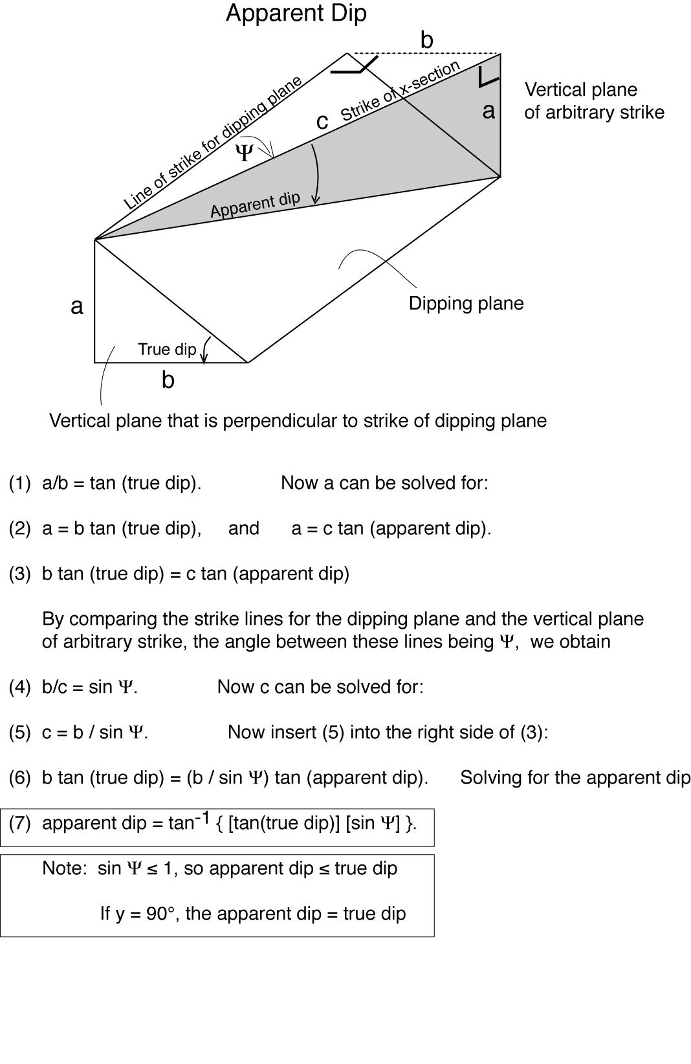
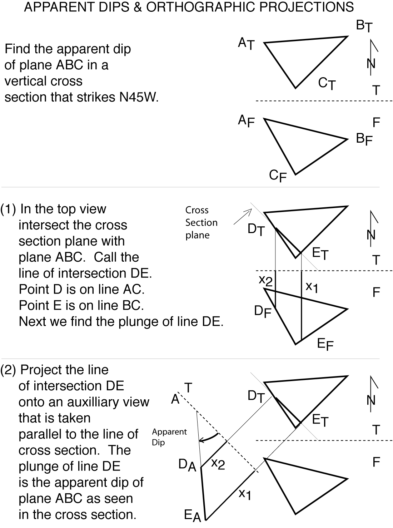
V Intersection of features in a point
A Intersection of two lines (L1 and L2) at a point
1 Intersection criteria
a The lines are not parallel (i.e., L1 x L2 ≠ 0)
b The lines lie in the same plane
2 Equations for two lines in a plane
a or
b or
where the subscripted “a” terms are direction cosines.
(in matrix form)
d A X = B (matrix shorthand)
e Solution of simultaneous equations (i.e., determining where the lines intersect) by Cramer’s Rule

where

B Intersection of three planes
1 Graphical solution: intersect two of the planes to find the line of intersection, and then intersect that line with the third plane.
2 Equations of the planes
Equation for plane P1: n1•x = d1
Equation for plane P2: n2•x = d2
Equation for plane P3: n3•x = d3
In matrix form
or [A][X] = [B]
Note that the dimensions are consistent!
3 Solution by Cramer's rule
where
4 Solution using Matlab
If the matrix of direction cosines for the poles to the planes is A, and the matrix (vector) of distances from the origin to the planes is B, then the coordinates of the intersection point (X) is given by X = A\B.
5 Example: three planes that are a distances of 1, 2, and 3 from the origin as measured along the x, y, and z axes, respectively.
»alpha1 = 1; beta1 = 0; gamma1 = 0;
»alpha2 = 0; beta2 = 1; gamma2 = 0;
»alpha3 = 0; beta3 = 0; gamma3 = 1;
»A = [alpha1, beta1, gamma1; alpha2, beta2, gamma2; alpha3, beta3, gamma3]

A =
1 0 0
0 1 0
0 0 1

»d1 = 1; d2 = 2; d3 = 3;

»B = [d1;d2;d3]

B =
1
2
3

»X=A\B

X =
1
2
3
C Intersection of a line and a plane
1 A line (L1) and a plane (P1) intersect at a point
2 Point of intersection can be viewed as the intersection of 3 planes
a Plane P1
b Plane P2; P2 intersects plane P3 to give line L1. Plane P2 can be a vertical plane containing L1 (i.e., P2 strikes parallel to the trend of L1)
c Plane P3; P3 intersects plane P2 to give line L1. Plane P3 can be an inclined plane that contains L1 (i.e., the dip of P3 equals the plunge of L1, and the strike of P3 is 90° from the trend of L1).
D Intersection of two lines (L1 and L2)
1 Let line (L1) and line L2 intersect at a point
2 Point of intersection can be viewed as the intersection of 3 planes
a Plane P3 that contains both lines. Normal to P3 is along the cross product of L1 and L2.
b Plane P1 that intersects plane P3 to give line L1
c Plane P2 that intersects plane P3 to give line L2
(Planes P1 and P2 usually can both be vertical planes

Two Math Handbook References
Gellert, W., Küstner, H., Hellwich, M,. and Kästner, H., 1977, The VNR concise encyclopedia of mathematics: Van Nostrand Reinhold, New York, 760 p.
Tuma, J.J., 1979, Engineering mathematics handbook: McGraw-Hill, New ork, 394 p.
Lab 4
Read each exercise completely before you start it so that you understand the problem-solving approach you are asked to execute. This will help keep the big picture clear.

Exercise 1: Apparent dip (57 points total)

Graphical and trigonometric solutions
1) For plane ABC on the next page, graphically determine its strike and dip. Then find the apparent dip of plane ABC as seen in vertical cross section plane P2, which strikes N50°W. Check the apparent dip you obtain graphically against the apparent dip you obtain trigonometrically using the expression in the course notes. Enter your results in the table. Show your trigonometric calculations in the box below the table. (12 points total)
Strike of ABC  (graphical)  (3pts) | True dip of ABC  (graphical)  (3 pts) | Apparent dip of ABC  (Graphical)  (3 pts) | Apparent dip of ABC  (Trig.)  (3 pts)

.
.

Solution from cross-products of poles

You will now find the orientation of the line of intersection between plane ABC and the cross section plane from the cross product of the poles to the planes using two different techniques (see page 2). These solutions are to be done on Matlab. One-line Matlab commands can address each question. Include a printout of your work showing your answers. Annotate the printout as you see fit.

Poles from strike and dip
2) From the strike and dip of cross section plane P2 find the trend and plunge of its pole, first in degrees, and then in radians. The trend and plunge, measured in radians, are the two angular coordinates in a spherical reference frame; the third spherical coordinate, thie distance from the origin, has a value of 1 for a unit length vector. Then use the Matlab function sph2cart to find the direction cosines (Cartesian coordinates of a pole of unit length) from the spherical coordinates of the pole. (18 points total; 1 point per box)

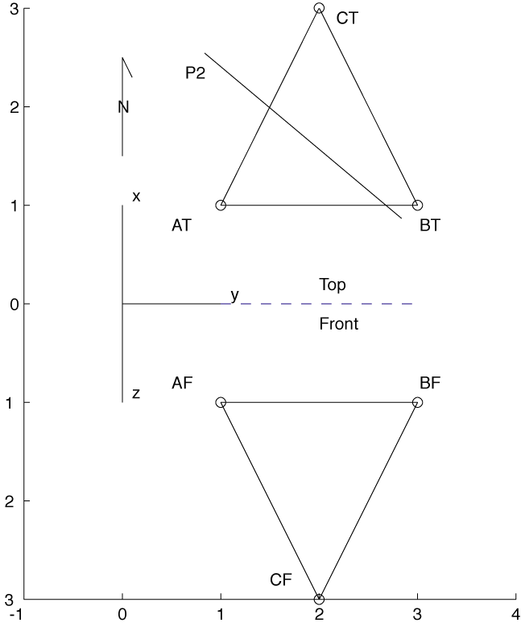

Plane ABC (plane 1)
S(°) | D(°) | P(°) | Pole plunge(°)

P( radians) | Pole plunge(radians) | α1 | β1 | γ1

Plane P2
S(°) | D(°) | P(°) | Pole plunge(°)

P( radians) | Pole plunge(radians) | α2 | β2 | γ2

At this point one could proceed directly to question 11, and you are welcome to do that if you want to maintain the flow of the exercise (if you do that though, you still need to answer questions 3-10). However, one might want to pause to check the intermediate results to make sure a mistake hasn’t been made already that might only become apparent at the end of the exercise. So a powerful, direct alternative method for obtaining the direction cosines for the poles is introduced in questions 3-10.

Poles directly from coordinates of points in plane (just for plane ABC)
3) Find the x,y,z coordinates of points A, B, and C in terms of the dimensionless units on the axes. Give the coordinates to the nearest 0.1 units. NOTE THAT POSITIVE Z POINTS DOWN, so the coordinates given in the attached figure for the front view should have increasing positive values with distance below the top plane. (9 points total; 1 point/box)
 | x | y | z
Point A
Point B
Point C

4) Enter the x,y,z coordinates of points A, B, and C (i.e., vectors OA, OB, and OC, respectively) into Matlab as 1-row, 3-column arrays. For example: Q = [3,4,5]. (3 points total)

5) Using Matlab and vector subtraction, find vectors AC and AB, where AC “points” from point A to point C, and AB “points” from point A to point B. (2 points)
 | x | y | z
Vector AC
Vector AB

6) Using Matlab, find the x, y, and z components of N1, where N1 is the cross product AC x AB, and write its x,y,z components in the table below. (1 point)
 | x | y | z
Vector N1

7) Using the square root function in Matlab (sqrt) and the dot product of a vector with itself, find the length L1 of vector N1. L1 = |N1|. (1 point)
L1 =|N1|

8) Divide the x, y, and z components of N1 by L1 to find the x,y,z components of the unit vector n1; we call these unit vector components 1,  . respectively. (1 point)
 | α1 | β1 | γ1
Vector n1

9) Using Matlab’s cart2sph function, find the trend and plunge of n1 in degrees. Note that cart2sph yields the trend and plunge only for x = north, y = east, z = down. (2 points)
n1 trend (degrees) | n1 plunge (degrees)
10) Check: is this result consistent with the graphical solution for the strike and dip of the plane ABC for question 2, yes or no? (1 point)

Resumption of solution
For questions 11-13, fill out the table below.
11) Using Matlab and the direction cosine values for the planes addressed in question 2, find V2= n1 x n2 . (1 point)
12) Find the length L2 of vector V2. L2 = |N2|. (1 point)
13) Divide the V2 components by L2 to get the components , ,  of unit vector v2. (1 point)
 | V2_{x} | V2_{y} | V2_{z} | L2 =|V2| | α2 | β2 | γ2
Vector V2

14) Using your answer to question (13) and Matlab’s cart2sph function, find the trend and plunge of v2 in degrees. (2 points)
 | Trend (degrees) | Plunge (degrees)
Vector v2

15) Explain what the answer to question (14) is in terms of the original problem as described in question 1: what is v2? Write your answers below. (2 points)

Think about what you have done. You have prepared a graphical solution, and you checked your solution by two independent algebraic methods. The graphical solution probably did not take nearly as long to do as the last algebraic solution for this one problem. The graphical solution also lets you “see” what is going on visually. You can save your algebraic solutions on a computer, however, and do another problem rapidly just by changing the input values of question 5. If you have many problems to do, the computer will be faster.

Exercise 2: Equation of a plane: n•v = d (10 points total)
In this exercise you will find the normal form of the equation of plane ABC (see page 1).
Start by checking to make sure that your solution for n1 (the unit normal) is correct.

1) Take the dot product of AC and n1 and write it below. (1point)

2) Take the dot product of AB and n1 and write it below. (1point)

3) Check: n1 is supposed to be perpendicular to the ABC plane. Describe below whether or not your answers to (1) and (2) support this, and say why. (2 points)
.
.

4) Find d1 = n1 • v, where v = OA, the vector from the origin to point A. (1 point)

5) Find d2 = n1 • OB, where v = OB, the vector from the origin to point B. (1 point)

6) Find d3 = n1 • OC, where v = OC, the vector from the origin to point C. (1 point)

7) What is the meaning of your answers to questions 4-6? (1 point)
.
.

8) Check: is this consistent with the points as plotted in the figure? (1 point)
.

9) Write the equation for plane ABC in normal form (see section II.D.1), filling in the terms that you know. (1 point)
Exercise 3: Point-of-intersection problem (85 pts total)

A scientific team plans to test whether earthquakes along the Snake Eyes Fault can be triggered by injecting water down boreholes into the fault. The team needs you to tell them where the borehole will intersect the fault. Here is the geometric data for one borehole option:
Location of drill pad Borehole trend Borehole plunge
D 0m east, 0m north, el. = 1000m 45° 70°
The fault plane has been located at three spots:
A 1000m east 0000m north el. = 500m
B 0000m east 1000m north el. = 500m
C 1000m east 1000m north el. = 800m

Graphical Approach
1) Plot the locations of the above 4 points on a map (4 points), remembering to include a title, scale and north arrow (3 points). (7 points).

2) Find the strike and dip of the fault plane (Plane 1) graphically, then find the trend and plunge of the pole to the plane, and write the values in the table below. (8 points).
 | S  (3pts/box) | D  (3pts/box) | P  (1 pt/box) | Pole plunge  (1 pt/box)
Plane 1 (fault)

3) Construct a cross section along a vertical plane that goes through the drill pad of the borehole, with the strike of the cross section plane matching the trend of the borehole. In this cross section plane show the borehole (1 point), the Snake Eyes fault, which will appear with an apparent dip (4 points), and show the intersection of the borehole with the fault plane. (2 points). The cross section should also have a title (1 point), a vertical scale (1 point), and something to designate its orientation (1 point). This problem is similar to that of Exercise 1. (10 points total)

4) Measure the distance along the borehole from the drill pad to the fault. Give the distance in terms of “meters in the field”, not “cm on the piece of paper.” (2 points).

Distance along the borehole from the drill pad to the fault (meters)

Algebraic Approach (Solution of simultaneous linear equations, section V B)
Much of the rest of exercise requires using Matlab. Include a printout of your Matlab work.

5) Find the strike and dip of the vertical plane (Plane 2) that contains the borehole, then find the trend and plunge of the pole to the plane, and write the values in the table below. (8 points).
6) Find the strike and dip of an inclined plane (Plane 3) that contains the borehole and that dips at an angle equal to the borehole plunge, then find the trend and plunge of the pole to the plane, and write the values in the table below. (8 points).
 | S  (3pts/box) | D  (3pts/box) | P  (1 pt/box) | Pole plunge  (1 pt/box)
Plane 2 (vertical)
Plane 3
(inclined)

Write the answers for questions 7-9 in the table below.
For the following questions use a reference frame where x=north, y=east, z=down. Make sure your answers are consistent with this frame.
7) Using Matlab, find the direction cosines of the poles to each plane. (9 points).
8) Write the x,y,z coordinates of a point in each plane. (9 points).
9) Find the distance (d) from the origin to each plane along the direction of the appropriate unit normal. Write the answers in the right-hand column of the table. (3 points)
 | α  (1 pt/box) | β  (1 pt/box) | γ  (1 pt/box) | x,y,z  (1 pt/box) | d  (1 pt/box)
Plane 1 (fault) |  |  |  | x:  y:  z:
Plane 2 (vertical) |  |  |  | x  y  z
Plane 3  (inclined) |  |  |  | x  y  z

10) Check: do the normals for Plane 1, Plane 2, and Plane 3 seem to point in the right direction based on a qualitative check of α, β, and γ? State your reasoning below. (3 points total)

The remaining questions deal with the location where the borehole intersects the fault.
11) Fill out the matrices below for the equation AX = B, for which you know values. Circle the boxes that you need to solve for to find where the borehole intersects the fault. Then use Matlab to solve for the coordinates of where the borehole would intersect the fault, and fill in those coordinates in the appropriate matrix below (1 point per box; 1 point for circling the correct matrix; 16 points total).

 |  |  |  |  | =
 | A |  |  | X |  | B

12) Using Matlab, determine the length of the borehole based on the coordinates of its drillpad and the coordinates of where it would intersect the fault. Compare the answer here with the answer from question 3 of Exercise 2. (2 points).

Note: although you were not asked to do this here, you could have calculated the direction cosines for the normals to the planes directly from the coordinates of three points in each plane, just as you did in Exercise 1.

