2

The Asian Monsoon: Global perspectives

Kevin E. Trenberth, James W. Hurrell and David P. Stepaniak

National Center for Atmospheric Research
P. O. Box 3000
Boulder, CO 80307

email: trenbert@ucar.edu
Fax: (303) 497 1333

22 October 2003

Original outline:
2.1 Distribution of heat sources and sinks
2.2 Global circulation (divergent circulation, SLP, low- and upper-level winds)
2.3 Precipitation regimes
2.4 Global energy and water cycle
2.5 Global monsoon and regional components

2.1 THE GLOBAL SETTING
2.2 DATA
2.3 The mean seasonal monsoon-related variations
    - Basic climate variables
    - The atmospheric circulations
2.4 DIABATIC PROCESSES: HEAT SOURCES AND SINKS
2.5 REGIONAL MONSOONS
2.6 DISCUSSION AND CONCLUSIONS

2.1 The global setting

The term “monsoon” stems from seasonal variations in winds but it is now more generally applied to tropical and subtropical seasonal reversals in both the atmospheric circulation and associated precipitation. These changes arise from reversals in heating and temperature gradients between continental regions and the adjacent oceans with the progression of the seasons, and the extremes are often best characterized as “wet” and “dry” seasons rather than summer and winter. Moreover, in spite of the absence of seasonal migration of the Intertropical Convergence Zones (ITCZs) over most of the Pacific and Atlantic Oceans between the hemispheres, it is evident that there is a global monsoon, by which we mean a global-scale persistent overturning of the atmosphere throughout the Tropics and subtropics that varies with time of year (Trenberth et al. 2000). The reason why the global monsoon should be emphasized is because of the coordination among regional monsoons brought about by the annual cycle of the solar heating and the apparent connections in the global divergent circulation necessitated by mass conservation. The dominant monsoon systems in the world are the Asian-Australian, African and the American monsoons, although the latter has not been clearly identified with wind reversals (Webster et al. 1998). In these sectors, the wet zone migrates from one hemisphere to the other following the sun, and the large-scale overturning atmospheric circulation reverses.
The picture of a monsoon overturning circulation as something like a thermally driven sea breeze on a larger scale, and therefore modified by the Earth’s rotation, is however, highly idealized. Moreover, often only the cross-equatorial overturning comprising the local Hadley circulation has been emphasized: it is referred to as the “lateral monsoon” in Webster et al. (1998). Strong rising motions in the summer hemisphere at ~10° latitude are, to some extent, compensated by subsidence at ~20˚ latitude in the winter hemisphere. However, in the Tropics, a large component of the overturning is not meridional but is zonally−oriented and is referred to as the “Walker circulation” or the “transverse monsoon” for overturning toward the west (Webster et al. 1998). Over some parts of the Tropics, including the tropical central and eastern Atlantic and Pacific Oceans, the ITCZ resides between ~5 and 10˚N year round. However, it does not follow that the downward branch is similarly anchored.
The three dimensional character of the atmospheric circulation is dominated by the rotational (non-divergent) component, which is strongly influenced by the divergent circulation that is more physically linked to the diabatic processes that force the overall circulation. Hence, in association with the monsoon rains, an upper level anticyclone accompanies a continental heat low-pressure region at low levels while the reverse pattern is often seen over adjacent oceans. Large momentum transports occur in the meridional circulation and strongly influence the subtropical jet streams. The strongest jet of over 70 m s⁻¹ lies off the east coast of Asia in boreal winter, while off the east coast of Australia in austral winter the strongest jet is more than 50 m s⁻¹. Both are directly associated with the regions of the globe where and when the strongest overturning occurs in lower latitudes.
The existence of the direct overturning circulation implies that heat is being transported to cooler regions. Energy is generated from sources of heating in the atmosphere and, overall, there has to be transport by the atmosphere and ocean from source to sink. Heating occurs in the Tropics, where it is already hot, and cooling occurs at higher latitudes. Atmospheric energy is gained in the Tropics and lost at higher latitudes (Webster 1994; Trenberth and Stepaniak 2003a). A small amount is converted to kinetic energy and regained as friction heating. On the whole, air parcels moving polewards must have a higher moist static energy than air parcels moving equatorward. In middle latitudes the poleward heat transport is carried out by transient baroclinic eddies and stationary waves, while in the Tropics the transport is dominated by large-scale overturning (Trenberth and Solomon 1994; Trenberth and Stepaniak 2003a). Thus the Hadley and Walker cells are thermally driven cells that transport moist static energy (Trenberth and Stepaniak 2003b). The dominant energy outflow center, coinciding closely with the region of highest sea surface temperature (SST) in the oceans, migrates back and forth across the equator following the sun.
Another key issue is the extent to which one should think of the global monsoon as a steady circulation (Ramage 1971), albeit made up of local small-scale disturbances (Fein and Stephens 1987). Thus there are active and break periods in regional monsoons, and many identified sub-seasonal variations, as well as pronounced interannual variability (e.g., Webster et al. 1998).
Accordingly, in this chapter we set the stage for regional aspects by documenting the global scales of the atmospheric monsoon circulation, and its links to the surface, with an emphasis on the annual cycle. A series of fields is produced that relate to the development of the global monsoon circulation for the two solstitial seasons of June-July-August (JJA) and December-January-February (DJF) and their differences, although we note the astronomical definition of the seasons is more appropriate over the oceans (Trenberth 1983). The seasonal differences highlight the seasonally varying components and they directly relate to the monsoons.

2.2 Data

We use the Climate Prediction Center (CPC) Merged Analysis of Precipitation (CMAP) estimates from Xie and Arkin (1997), the optimal interpolation (OI) SST analysis of Reynolds et al. (2002), and surface air temperatures from Jones et al. (1999). At the top-of-atmosphere (TOA), we use the Earth Radiation Budget Experiment (ERBE) measurements of radiation for the period February 1985 to April 1989 (Trenberth 1997; Trenberth and Stepaniak 2003b). In the free atmosphere results are obtained using the National Centers for Environmental Prediction/National Center for Atmospheric Research (NCEP/NCAR) reanalyses (Kalnay et al. 1996).
A comprehensive description of the divergent circulation of the atmosphere has been elusive owing to the difficulty of obtaining reliable fields. Errors in observations are often of the same order as the expected divergent component itself and huge observational gaps exist over the oceans. Accordingly, the only viable approach is via four-dimensional data assimilation (4DDA). Recent results (Trenberth et al. 2000) from the two major reanalyses (NCEP/NCAR and European Centre for Medium Range Weather Forecasts (ECMWF) (Gibson et al. 1997)) agree reasonably well and therefore provide a new level of confidence. The NCEP/NCAR results from 1979 to 2001 have also been used to determine the diabatic heating and relationships to energy transports for the mean annual cycle and the interannual variability (Trenberth and Stepaniak 2003a, b).
The series of plots that follow focus on the domain to 60˚ latitude in order to allow contours to be selected that reveal the character of the fields (which often are otherwise dominated by large values in polar regions).

2.3 The mean seasonal monsoon-related variations

2.3.1 Basic climate variables

SST is a fundamental coupled variable in climate. It results from both the external forcing of the planet governed by the orbit of the Earth around the sun and the resulting radiant fluxes, and through adjustments of the ocean surface to wind fields, surface fluxes and ocean dynamics. However, from an atmospheric viewpoint, it is often convenient and useful to think of SST as the lower boundary forcing of the atmosphere above the oceans. The seasonal mean SST fields for JJA and DJF, as well as their difference, are given in Fig. 1. Warmest waters, exceeding 29˚C, reside in the western tropical Pacific (the “Warm Pool”) and migrate back and forth across the equator with the seasons. Seasonal changes of 2 to 3˚C occur in mid-latitudes but the greatest gradients of change occur within the Tropics. The latter tend to become reflected in low-level atmospheric temperatures and thus sea level pressure gradients and surface winds. Nevertheless, these effects are fairly modest and tend to be overwhelmed by the rotational component of the flow.
The annual range of SST and surface air temperature (Fig. 2), measured by JJA minus DJF, highlights land-sea contrasts and relatively small annual changes over the oceans. These features reflect the very different heat capacities of ocean versus land and the depth of the layer linked to the surface. The largest ranges occur over the continents, and except for the subtropical continents of the Southern Hemisphere (SH), values are smaller in the SH than in the Northern Hemisphere (NH) at corresponding latitudes. The largest annual ranges exceed 30˚C over northern continents. The net result is that the large land-masses are at least as warm as the warmest parts of the oceans in summer, but much colder in winter. The gradients between land and ocean are most pronounced in winter because radiative losses over land lead to dense air and high surface pressures that make for a stable atmosphere. In contrast, in summertime, hot land conditions lead to sea breeze effects which bring in low level moisture and summertime rains: the monsoons, that naturally act to cool the surface. Hence the temperatures over land in summer are partly a consequence of the monsoons and not just a forcing. Of course the atmospheric circulation also plays a significant role in wintertime in moderating radiative effects.
Sea level pressure fields (Fig. 3) reflect many aspects of these changes. The main features are the subtropical anticyclones that are strongest in the winter hemisphere and extend to higher latitudes in the northern winter, most notably in the Siberian High where values exceed 1035 hPa. However, the oceanic anticyclones in northern summer over the Pacific and Atlantic are also strong persistent features directly linked to regional monsoon circulations (Hoskins 1996; Chen et al. 2001; Rodwell and Hoskins 1996, 2001). Tropical continents are regions of low pressure, often as part of the monsoon trough. Low pressures extend over the oceans, especially in the near equatorial trough and Warm Pool region, and vary over the latter region following the SST changes. The Icelandic Low in the North Atlantic and Aleutian Low in the North Pacific are strongly evident in winter and highlight the relative warmth of the northern oceans compared with the neighboring continents. The circumpolar trough around Antarctica is a related feature but is present year round owing to the cold high Antarctic continent centered near the pole. The differences in sea level pressure between the two seasons map the land-sea contrast in the NH and temperature gradients between hemispheres well. More subtle effects arise from the tendency for the subtropical highs over the SH to shift polewards and weaken slightly in summer, away from the subtropical continents.
Average precipitation amounts (Fig. 4) better define the divergent part of the atmospheric circulation and key aspects of the monsoons. Note that plotting the JJA−DJF differences in mm day^{–1}, rather than as a percentage, emphasizes the tropical regions. The ITCZs in the near-equatorial trough stand out, as does the South Pacific Convergence Zone (SPCZ) with its southeastward extension toward higher latitudes, especially in southern summer. Its extension often has frontal characteristics and has been referred to as a “graveyard” for fronts (Trenberth 1976). Similarly the ITCZ, located about 5 to 10°N over the Pacific and Atlantic oceans during the solstitial seasons, is strongest in boreal summer. Clearly evident in the precipitation fields is the monsoonal rains over southern Asia, central Africa, and central and South America, the latter also involving the South Atlantic Convergence Zone (SACZ). Although the seasonal change is most striking over the land areas, it is also quite large over the oceans. The large-scale pattern of change is one of enhanced rains from 5 to 15°N, extending to about 35°N over Asia in northern summer and similarly over about 5°N to 30°S in the SH summer. In JJA−DJF differences, the dipole structures highlight the monsoon rains and movement of the primary zones from one hemisphere to the other.

2.3.2 The atmospheric circulations

The general circulation in the atmosphere is illustrated by flows in the lower troposphere at 850 hPa and in the upper troposphere at 200 hPa. The total vector winds for JJA, DJF and their differences (Figs. 5 and 6) are superposed on contours of geopotential height at these two levels. The lower tropospheric geopotential height resembles the sea level pressure field. The equatorial trough in DJF, the major monsoon trough over Asia in JJA, the subtropical anticyclones with strong southeast and northeast trade winds, and the higher latitude westerlies are all notable features. At 200 hPa the strong westerlies in both hemispheres dominate along with embedded subtropical jet streams that are strongest over East Asia in DJF and east Australia in JJA. At both tropospheric levels, the dominant flow is the rotational component that is largely related to the monsoon circulation. For instance, strong meridional equatorward flow on the eastern side of the subtropical anticyclones is associated with large-scale subsidence in accord with an approximate Sverdrup balance whereby βv = f∂ω/∂p; where f is the Coriolis parameter, β is its meridional gradient, v is the meridional velocity and ω is the vertical p-velocity whose vertical derivative is related to the divergence (Rodwell and Hoskins 2001). Such a relationship, incidentally, also means that the maximum divergence is not in the center of the anticyclonic circulation. Seager et al. (2003) suggest that interactions of this flow at the surface with SSTs and ocean dynamics also play a role in strengthening the features of subtropical anticyclones.
Of more interest with respect to monsoons is the divergent part of the flow itself, shown with the velocity potential (Figs. 7 and 8) as a very smoothed depiction of the global-scale divergence field. As low-level convergence at 850 hPa is generally manifested as upper level divergence at 200 hPa, these fields strongly indicate the large-scale monsoonal overturning circulations. The JJA−DJF differences are especially relevant for revealing the seasonally varying flow, with the enormous Asian-Australian monsoon linked to that in Africa, and the somewhat separate North and South American monsoons. However, closer examination also indicates that the upper-tropospheric divergence at 200 hPa is not an exact match for the convergence at 850 hPa. Over Africa, for instance, shallower overturning is often present in the monsoon (Trenberth et al. 2000) and an alternative analysis is desirable to examine the vertical structure of the overturning.
However, we first present the corresponding vertical motion fields at 500 hPa (Fig. 9). This field is derived from the reanalyses and, while independent of the precipitation field, is strongly dependent on the assimilating model. Nevertheless, there is a marked correspondence between Figs. 9 and 4 throughout the Tropics and subtropics, indicating the predominance of the precipitation occurring in association with the mean flow rather than high frequency transients. Accordingly, the monsoon rains are associated with zones of upward motion that switch from south of the equator over Africa, Australia and South America in DJF to north of the equator over Africa, Asia and central America in JJA. The JJA−DJF differences (Figs. 9 and 4) also agree well with each other except that the central Pacific ITCZ may be weak in the NCEP reanalyses ω field and the SPCZ a bit too zonal. In other words, some of the differences may not be real. Nevertheless, these two fields do measure very different things as precipitation occurs only in upward motion, and therefore transients can lead to precipitation even if the time-mean flow is for downward motion.
To explore the global monsoon and its vertical structure in more detail, Trenberth et al. (2000) performed a complex empirical orthogonal function (CEOF) analysis of the mass-weighted divergent circulation that brings out two dominant modes with essentially the same vertical structures in all months of the year. The vertical structure of the first mode (Fig. 10) is plotted as vectors, with the arrows free to rotate through 360°. All vectors tend to point either to the left or right indicating either in-phase or out-of-phase relations, respectively. The vectors are so arranged that they can be directly interpreted as showing the large-scale overturning in the upper and lower branches of, for instance, the Hadley circulation. For CEOF1 (Fig. 10), the vertical structure is simple with a maximum in vertical motion at about 400 hPa, divergence in the upper troposphere that peaks near 150 hPa and decays to zero amplitude above 70 hPa, and convergence in the lower troposphere with a maximum at 850 hPa (NCEP) or 925 hPa (ECMWF; not shown). Spatially this mode has a rich three-dimensional structure that evolves with the seasons (Fig. 10). It accounts for 60% of the annual cycle variance of the divergent mass circulation and includes the Hadley circulation as well as three overturning transverse cells. These include the Pacific Walker circulation, an Americas-Atlantic Walker circulation, both of which comprise rising motion in the west and sinking in the east, and a transverse cell over Asia, the Middle East, North Africa and the Indian Ocean that has rising motion in the east and sinking toward the west. These exist year round but migrate and evolve considerably with the seasons and have about a third to half of the mass flux of the peak Hadley cell. The annual cycle of the two Hadley cells reveals peak strength in early February and early August in both reanalyses (Trenberth et al. 2000).
In DJF (Fig. 10) the large-scale low-level convergence and associated upper level divergence in CEOF1 is most apparent north and east of Australia near 10°S, and the SPCZ is clearly a part of this pattern. In the Indian Ocean the ITCZ is also evident near 10 to 15°S. Similarly, strong low-level convergence occurs over the Amazon while subsidence over the tropical eastern Pacific is present as the downward branch of the Walker circulation. The latter is slightly stronger relative to the Hadley circulation in the NCEP reanalyses (Trenberth et al. 2000). A distinctive line of convergence in the upper troposphere occurs from 90°E to 170°W along about 30 to 35°N, penetrating farthest north near Japan, which bears a striking resemblance to the position of the core of the subtropical jet stream where it exceeds 50 m s⁻¹ in January. A primary forcing of the rotational zonal wind component comes from the term fv_{d}, where v_{d} is the divergent meridional wind component. Since the Coriolis parameter increases with latitude, this term reaches a maximum just short of the convergence line.
The corresponding vertical motion fields (not shown) are fairly similar to those in Fig. 9 and reveal that the pronounced subsidence in the South Pacific high is present all year, while the subtropical high in the North Pacific is much stronger in summer. The migration across the equator of the upward motions is evident in Africa and from the Amazon region to the Mexican highlands.
While some low-level convergence is apparent in CEOF1 in the southern Tropics over Africa, the main features over Africa and Australia are accounted for by the second mode (not shown), which involves relatively shallow but vigorous overturning with the maximum vertical velocities near 800 hPa, outflow from 750 to 350 hPa, and inflow peaking at 925 hPa (Trenberth et al. 2000). It is especially strong over Africa, influences the Middle East, has a signature over Australia and also is an important component of the overturning in the tropical eastern Pacific and Atlantic, and thus of the convergence zones in these regions.

2.4 DIABATIC PROCESSES: HEAT SOURCES AND SINKS

The fundamental forcing of the atmospheric circulation and climate ultimately relates to the radiation budget of the planet. To further set the stage for understanding the seasonal monsoon variations we therefore examine the diabatic forcings of the atmospheric circulation.
The absorbed solar radiation (ASR), outgoing longwave radiation (OLR), and the net radiation are given in Figs. 11, 12 and 13 for JJA, DJF and their difference. The dominant annual cycle forcing is the change in distribution of incoming solar radiation due to the orbit of the Earth around the sun. There are important effects from albedo and clouds, but they are secondary and the pattern of ASR has a strong zonal component that is dominated by orbital effects. Fig. 11 serves as an important reminder of just how large the seasonal variation is because JJA versus DJF differences exceed 200 W m⁻². It is interesting that the zero line is not on the equator but instead lies between 0 and 10°N for the most part. There is an important cloud signature in Fig. 11 although somewhat lost in the contours.
On the other hand, OLR (Fig. 12) is more uniform with latitude and season, and is well established to vary primarily with deep convection, owing to the high cold cloud tops. The signatures of the ITCZ, SPCZ, SACZ and monsoon-related clouds are clear. Also, in the Tropics, there is a very strong relation between the JJA−DJF differences in OLR and the patterns of change of precipitation (Fig. 4) and vertical motion (Fig. 9). In the extratropics, however, the OLR signature is much more strongly related to temperature (Fig. 2).
The cloud signature in ASR is well matched by that in the OLR signal and when the net radiation (Fig. 13) is considered there is remarkable but well-known cancellation (Hartmann et al. 2001). The net radiation seasonally is dominated by the ASR changes. Once again the zero line in the net radiation lies just north of the equator. It is this pattern of net radiation that ultimately directly drives the monsoons and their seasonal reversals.
Over land, the thermal inertia is quite small, and thus there is a tendency for land temperatures to respond to the radiative imbalance. However, over the oceans, surface heating in summer warms the upper ocean, which becomes strongly stratified (as warm water is less dense) even though some heat is mixed to lower layers by wind. In winter, surface cooling results in denser surface waters which are apt to sink, triggering convection, and bringing warmer waters to the surface from below. Surface cooling is however greatest from cold dry continental air outbreaks over western oceans where boundary currents such as the Gulf Stream lie, and turbulent surface fluxes can exceed 1000 W m⁻² for short periods of time (e.g., Neiman and Shapiro 1993) and over 300 W m⁻² over monthly and seasonal averages. Seasonal heat uptake by the oceans can exceed 100 W m⁻² in the subtropics in summer which is then released to the atmosphere in winter (e.g., Trenberth and Stepaniak. 2003b), strongly mitigating the season cycle of solar radiation.
Estimates of vertically-integrated diabatic heating in the atmosphere (Q₁−Q_{f} ) are based on atmospheric heat budgets using NCEP reanalyses, computed as a residual (Trenberth and Stepaniak. 2003 a, b). Note that Q₁ includes the small frictional heating (Q_{f} ) so that their difference is the diabatic heating in the atmosphere, presented in W m⁻² (Fig. 14). The reader will immediately recognize the strong resemblance with Figs. 4 and 9. Therefore it is also desirable to present the vertically-integrated latent heating component, Q₂ = L(P−E), where L is the latent heat of condensation, P is precipitation rate and E is evaporation rate. Q₂ is shown in Fig. 15 along with the corresponding vertically-integrated divergent component of the total flux of water vapor transport (Trenberth and Stepaniak 2003 a, b). The difference between these two quantities, Q₁−Q_{f} −Q₂, is directly related to the divergence of the total atmospheric energy transports (Fig. 16) on an annual basis when changes in storage of energy in the atmosphere can be ignored. Moreover, for long term annual means the difference between this and the net radiation (Fig. 13) should be close to zero over land and correspond to divergence of ocean heat transports over the oceans. The implied ocean heat transports have been verified by comparisons with direct measurements in ocean sections by Trenberth and Caron (2001) and have an advantage of providing a global picture.
These figures reveal that the dominant diabatic heating in the Tropics comes from latent heating associated with precipitation. The heating is associated with regions of upward motion and the low level convergence of moisture by the atmospheric circulation (Fig. 7, and see Fig. 15) itself.
The atmospheric circulation naturally responds to these diabatic forcings and, at the same time, transports heat, energy and moisture. The low frequency part of the flow plays a dominant role throughout the Tropics and can be depicted by monthly means, while transients, depicted by within-month variations, are prominent in the extratropics. The total energy divergence and the divergent component of the transports are given in Fig. 16 for the quasi-stationary and transient components (Trenberth and Stepaniak 2003b). The former dominates in the Tropics and is more directly associated with the monsoons and the Hadley and Walker circulations. But note how the pattern of diabatic heating associated with latent heating has largely disappeared to be replaced by moisture sources. In this depiction the energy transport by the overturning circulations is fairly modest. In the Asian summer monsoon (top panels), the divergence of energy from the upward branch is transported mostly to 30°S in the Indian Ocean where it is further transported polewards by the transient eddies. In the Pacific and Atlantic the overturning transports energy northwards to about 30°N, where it is transported farther north in the ocean storm tracks. In these areas, there is also a component transported into the SH.
In DJF and in the inter-seasonal differences (JJA−DJF), the strong NH stationary waves dominate although the storm tracks over the ocean also play a major role. The difference also reveals the huge switch over the northern oceans from being a source of heat in winter to a sink in summer while the land acts in reverse.
From these figures it is clear that, from an energy budget standpoint, latent heating drives the upward branch of the monsoonal overturning circulation. There is a strong balance between adiabatic cooling associated with rising air and latent heating. However, the latent heating is also a response to the circulation itself and not a fundamental cause. The original source of the latent heating is the moisture convergence and thus ultimately evaporation from the surface, primarily over the oceans. Hence the latent heating is linked to the absorbed solar radiation. However, the latter is taken up and stored within the ocean so that maximum SSTs tend to occur at the end of the summer season in the extratropics. Moreover, some aspects of the evaporation of moisture into the atmosphere are linked to its transport and convergence into precipitation zones associated either with the ITCZ, SPCZ, SACZ or monsoon rains. This is because the evaporation itself is also partly a result of the circulation and the turbulent fluxes into the atmosphere. In order for all this to take place, there has to be an overturning circulation in the atmosphere.
The overturning circulation in the atmosphere in low latitudes, where the Earth’s rotational effects are weak, is the main way the tropical atmosphere can move energy around (in contrast to baroclinic processes at higher latitudes). Therefore there also has to be a heat sink (cooling) in the downward branch of the circulation to balance the warming by subsidence. Conventional wisdom suggests that this cooling, usually in the subtropics, is primarily associated with OLR emitted to space. This is partly the case, but once again, the relatively clear skies are a consequence of the circulation and thus are a feedback and not a fundamental cause. Instead, on monthly and longer time scales the atmospheric energy transports are continuous between the Tropics and extratropics in spite of the very different mechanisms for distributing energy, namely the overturning Hadley-type or monsoonal circulation in the Tropics and the baroclinic eddies in mid-latitudes (Trenberth and Stepaniak 2003a, b). There has to be a very tight link, therefore, between the two. Consequently it has been established that the major part of the cooling in the subtropics over the oceans comes from divergence of energy (cooling) by the baroclinic waves, which in turn are often organized into storm tracks (Fig. 16). The preferred storm tracks are slightly polewards of the main jet streams, which are a consequence of the convergence of momentum transports by both the overturning and the baroclinic eddies. Effectively, the baroclinic eddies carry energy to higher latitudes where it is eventually radiated to space as OLR. Consequently the cooling in the downward branch of the overturning circulations is linked to OLR diabatic forcing through radiation to space at all subtropical and extratropical regions.
Normally there are two Hadley cells in the atmosphere. One is in each hemisphere. In the equinoctial seasons, both can be seen with roughly comparable strength (see Trenberth et al. 2000). But in the solstitial seasons, the summer hemisphere Hadley cell is weak and the cell with subsidence into the winter subtropics becomes dominant (Figs. 5-10). At the top-of-atmosphere, the net radiation (Fig. 13) provides the main reason why this is so and the primary change is in ASR, not OLR. However, both the ASR and the OLR have major contributions at the Earth’s surface, and to properly interpret what is happening within the atmosphere, it is necessary to also examine the surface energy budget and the key role of evaporation in providing latent energy which in turn involves the oceans and their uptake and release of stored heat (Trenberth and Stepaniak 2003a, b).

2.5 REGIONAL MONSOONS

Six regions, from Trenberth et al. (2000), have been selected to illustrate and highlight meridional structures of the overturning monsoonal circulations. Here the ECMWF results are utilized because the extra 775 hPa level proves quite beneficial and the flow at 925 hPa is more distinctive. The sections, progressing eastward, include the following: (i) Africa: 10°E to 40°E. This is the land region at the equator, and so it does not include the South Atlantic; (ii) Australia-Asia: 60°E to 180°, covering the Asian-Australian monsoon; (iii) Pacific: 170° W to 90°W, containing the SPCZ and the ITCZ north of the equator; (iv) North America: 110°W to 80°W. This region is not ideal as the Central American isthmus is narrow and is not oriented strictly north-south; (v) South America: 80°W to 40°W, covering the main southern continent; and (vi) Atlantic: 30°W to 10°E. This region is a compromise as it includes some South American influences in the west.
We present the annual cycles of ω at 500 hPa and January and July cross sections of the divergent meridional circulation component. Note that because these sections are zonally limited, the circulation is not closed, and there is a third zonal dimension that conserves the mass flow. As the focus is on the direct overturning, the domain is limited to ± 50° latitude.
The ITCZ migrates back and forth across the equator over Africa as revealed by the ω field (Fig. 17), although subtropical subsidence is most pronounced in both hemispheres in the austral winter. In addition, the African monsoon is characterized by a complex vertical structure with shallow overturning below 600 hPa. In January, shallow direct cells exist near 15°N and 25°S, and in July the southern cell moves northward and is centered near the equator. Note that the subsidence at 35°N in July is not strongly linked to the ITCZ at 10°N, but comes primarily from the transverse cell.
For the Australia-Asia sector (Fig. 18), the ω annual cycle shows the more intense phases of the monsoons in January and July-August, with an additional upward motion branch near 30°N from April through August that reflects the elevated Tibetan plateau heat source and the Mei Yu and Baiu summer monsoon rainfalls in China and Japan, respectively (e.g., Kang et al. 1999). The corresponding cross section shows the dominant deep tropospheric overturning of the Hadley circulation. For the Pacific sector (Fig. 19), the ω annual cycle shows the ITCZ near 7°N year round but it appears weak in January when there is cancellation in the west as the SPCZ becomes more active. The latter also prevents a good view of South Pacific high subsidence except in the northern winter. The cross sections, however, clearly show the complex vertical structure of the deep tropospheric circulation combined with the shallow overturning below 600 hPa in both hemispheres. In January, ω at 500 hPa does not indicate the main activity at all.
The North American sector (Fig. 20) also strongly shows the shallow cell, especially south of the ITCZ. In fact, in January, there is subsidence everywhere at 500 hPa and upward motion only near 5°N below 600 hPa. In northern summer, the deeper Hadley circulation emerges more clearly although still with a shallow cell embedded.
The South American sector (Fig. 21) reveals the deep circulation over the Amazon in southern summer but with a large change in character in winter, where shallow overturning cells dominate north and south of the ITCZ. The ITCZ is about 7°N in southern winter and has double structure in October as it shifts to the SH.
In the Atlantic sector (Fig. 22), as in the Pacific, the strong ITCZ near 7°N year round is cancelled in the southern summer by migration of activity to the Amazon in the west. Again the cross sections show the importance of the shallow cells throughout the year.
The seasonal reversal in the overturning circulation implicit in the definition of the monsoon is present in Figs. 17-22 in all but the central and eastern Pacific and Atlantic sectors. It is certainly true in the South American sector, where some analyses of the total flow have not noted a seasonal reversal (e.g., see Ramage 1971; Webster et al. 1998). In the narrow North American sector where the transverse overturning is a non-trivial influence, the picture is not as clear when viewed only from the standpoint of a north-south section. While the eastern ocean areas can be legitimately excluded from being called regional monsoons, they nevertheless participate in the global monsoon through the changes in large-scale overturning.

2.6 DISCUSSION AND CONCLUSIONS

There have been many and varied definitions of what constitutes a monsoon, but until recently (Trenberth et al. 2000), it has not been possible to obtain a reliable perspective from the standpoint of the large-scale overturning in the atmosphere. Such persistent overturning that varies with the seasons is a key characteristic of the monsoons and has been the focus of this chapter. Nevertheless, there is also a substantial rotational component of the atmospheric circulation associated with monsoons, and this component plays a key role in transporting moisture. The migration of the sun back and forth across the equator is accompanied by the migration of the upward branch of the monsoon overturning circulation wherever continental land influences are present in the Tropics and subtropics. The presence of high topography also clearly enriches and enhances the monsoon. The main exceptions are the eastern Pacific and Atlantic Oceans where the ITCZs reside north of the equator year round, although these areas have a secondary role in the global monsoon.
The vertical structure of the global monsoon mass circulation remains largely unchanged throughout the year. The predominant deep overturning global mode acts throughout the troposphere and has a simple structure with a maximum in vertical motion at about 400 hPa, divergence in the upper troposphere strongest at 150 hPa and convergence in the lower troposphere. The mode decays to zero amplitude above 70 hPa. The Hadley circulation is part of the deep overturning mode, but so too are three transverse cells: the Pacific and Atlantic Walker cells, and an Asia-Africa transverse cell that overturns toward the west. While it is often useful to break down the global monsoon into these meridional and transverse components, the reality is the rich three- dimensional structure that evolves with the seasons (Fig. 10). The vertical motion patterns and precipitation in the Tropics and subtropics (both wet and dry areas) are largely accounted for by this dominant global monsoon mode.
The existence of the transverse cells has been known, at least schematically, for some time (see Krishnamurti 1971; Krishnamurti et al. 1973; Fein and Stephens 1987). The transverse cell that has rising motion in the east and sinking toward the west is strongest in January from northern Australia to the southern subtropical high in the Indian Ocean. By July the rising motion is over southeastern Asia with sinking over northern Africa and the Mediterranean, and is thus responsible for the so-called “Mediterranean climate” of clear skies and sunny days with rains infrequent in summer.
The relationship of the global monsoon to the more regional components was illustrated by the sectoral analyses of the previous section. The meridional cross sections highlight the importance of the shallow overturning cell in low level activity and annual cycle evolution of the monsoons.
Previous definitions of monsoon areas in terms of seasonal reversals in wind and precipitation (e.g., Ramage 1971) have not included the Americas. Webster et al. (1998) included the Americas on the basis of precipitation changes. Yet, from the divergent wind circulation (Figs. 20 and 21), the monsoon regions should include the Americas, although the picture is complicated by the meridional sectors for North and South America being somewhat offset. Nevertheless, there is clearly a monsoonal (direct) overturning that varies seasonally.
This chapter has emphasized the slowly varying circulation and long-term averages. Many analyses have been made of precipitation during the monsoon seasons and the active and break phases of the monsoons. An analysis of the steadiness of the monsoonal circulations highlights the important roles of high frequency transients, but it also singles out the monsoon regions as those where the circulation is much more steady than in other regions, such as the extratropics (Trenberth et al. 2000).
Previous analyses of interannual and interdecadal variations (e.g., see Webster et al. 1998) suggest that the global system does not vary coherently, but rather the regional monsoons and ENSO are in competition with one another, although those patterns evolve in time (e.g., Kumar et al. 1999). More vigorous activity in one sector is apt to create subsidence in another and help suppress activity, as the largest scales tend to be emphasized in the Tropics (Webster 1972). This is illustrated most simply by the pattern of the Southern Oscillation, which is the dominant mode of interannual variability overall (Trenberth and Stepaniak 2003b).

Acknowledgments

This research is partly sponsored by NOAA under grant NA56GP0247 and by a joint NOAA/NASA grant NA87GP0105.

References

Chen, P., M. P. Hoerling and R. M. Dole, 2001: The origin of subtropical anticyclones. J. Atmos. Sci., 58, 1827−1835.
Fein, J. S. and P. Stephens, 1987: Monsoons. John Wiley and Sons, New York, 384 pp.
Gibson, J. K., P. Källberg, S. Uppala, A. Hernandez, A. Nomura, and E. Serrano, 1997: ERA description. ECMWF Reanalysis Proj. Rep. 1, 72 pp.
Hartmann, D. L., L. A. Moy and Q. Fu, 2001: Tropical convection and the energy balance at the top of the atmosphere. J. Climate, 14, 4495−4511.
Hoskins, B., 1996: On the existence and strength of the summer subtropical anticyclones. Bull Amer. Met. Soc., 77, 1287−1292.
Jones, P.D., New, M., Parker, D.E., Martin, S. and Rigor, I.G., 1999: Surface air temperature and its variations over the last 150 years. Rev. Geophysics, 37, 173−199.
Kalnay, E., M. Kanamitsu, R. Kistler, W. Collins, D. Deaven, L. Gandin, M. Iredell, S. Saha, G. White, J. Woollen, Y. Zhu, M. Chelliah, W. Ebisuzaki, W. Higgins, J. Janowiak, K-C Mo, C. Ropelewski, A. Leetmaa, R. Reynolds, R. Jenne (1996) The NCEP/NCAR Reanalysis Project. Bull. Amer. Met. Soc., 77, 437−471.
Kang, I-S, C-H Ho, Y-K Lim and K-M Lau, 1999: Principal modes of climatological seasonal and intraseasonal variations of the Asian summer monsoon. Mon. Wea. Rev., 127, 322−340.
Krishnamurti, T. N., 1971: Tropical east-west circulations during the northern summer. J. Atmos. Sci., 28, 1342−1347.
Krishnamurti, T. N., M. Kanamitsu, W. J. Koss and J. D. Lee, 1973: Tropical east-west circulations during the northern summer. J. Atmos. Sci., 30, 780−787.
Kumar, K. K., B. Rajagopalan and M. A. Cane, 1999: On the weakening relationship between the Indian monsoon and ENSO. Science, 284, 2156−2159.
Neiman, P. J., and M. A. Shapiro, 1993: The lifecycle of an extratropical marine cyclone. Pt I: Frontal-cyclone evolution and thermodynamic air-sea interaction. Mon. Wea. Rev., 121, 2153−2176.
Ramage, C. S., 1971: Monsoon meteorology. Intl. Geophys. Ser. 15. Academic Press. 296 pp.
Reynolds, R. W., N. A. Rayner, T. M. Smith, D. C. Stokes and W. Wang, 2002: An improved in situ and satellite sea surface temperature analysis for climate. J. Climate, 15, 1609−1625.
Rodwell, M. J., and B. J. Hoskins, 1996: Monsoons and the dynamics of deserts. Quart. J. Roy. Met. Soc., 122, 1385−1404.
Rodwell, M. J., and B. J. Hoskins, 2001: Subtropical anticyclones and summer monsoons. J. Climate, 14, 3192−3211.
Seager, R., R. Murtugudde, N. Naik, A. Clement, N. Gordon and J. Miller, 2003: Air-sea interaction and the seasonal cycle of the subtropical anticyclones. J. Climate, 16, 1948−1966.
Trenberth, K. E., 1976: Spatial and temporal variations of the Southern Oscillation. Quart. J. Roy. Met. Soc., 102, 639–653.
Trenberth, K. E., 1983: What are the seasons? Bull. Amer. Meteor. Soc., 64, 1276–1282.
Trenberth, K. E., 1997: Using atmospheric budgets as a constraint on surface fluxes. J. Climate, 10, 2796−2809.
Trenberth, K. E., D. P. Stepaniak and J. M. Caron, 2000: The global monsoon as seen through the divergent atmospheric circulation. J. Climate, 13, 3969–3993.
Trenberth, K. E., and J. M. Caron, 2001: Estimates of meridional atmosphere and ocean heat transports. J. Climate, 14, 3433–3443.
Trenberth, K. E., and A. Solomon, 1994: The Global Heat Balance: Heat transports in the atmosphere and ocean. Climate Dynamics, 10, 107−134.
Trenberth, K. E., and D. P. Stepaniak, 2003a: Co-variability of components of poleward atmospheric energy transports on seasonal and interannual timescales. J. Climate, 16, 3690−3704
Trenberth, K. E., and D. P. Stepaniak, 2003b: Seamless poleward atmospheric energy transports and implications for the Hadley circulation. J. Climate, 16, 3705−3721.
Webster, P. J., 1972: Response of the tropical atmosphere to local steady forcing. Mon. Wea. Rev., 100, 518−540.
Webster, P. J., 1994: The role of hydrographic processes in ocean-atmosphere interactions. Rev. Geophys., 32, 427−476.
Webster, P. J., V. O. Magaña, T. N. Palmer, J. Shukla, R. A. Tomas, M. Yanai, and T. Yasunari, 1998: Monsoons: Processes, predictability and the prospects for prediction. J. Geophys. Res., 103, 14451−14510.
Xie, P, and P. A. Arkin, 1997: Global precipitation: A 17 year monthly analysis based on gauge observations, satellite estimates and numerical model outputs. Bull. Amer. Met. Soc., 78, 2539−2558.
Figures
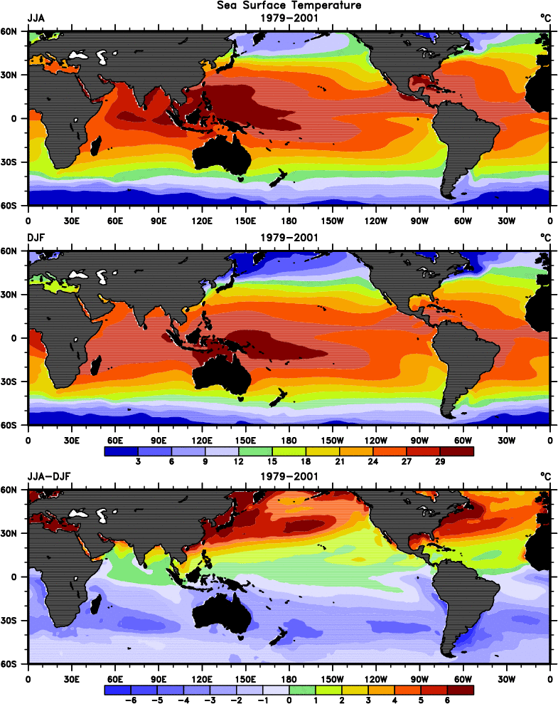

Fig. 1. Sea surface temperatures for 1979-2001 averaged for JJA (top), DJF (middle) and their difference JJA−DJF (bottom). The contour interval in the top two panels is 3°C and 1°C in the bottom panel.

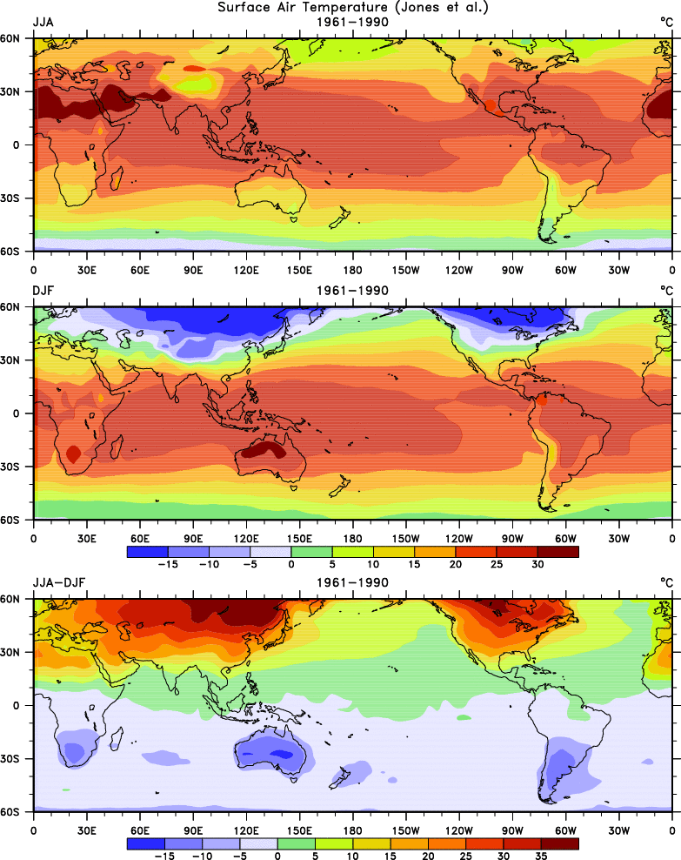

Fig. 2. Surface air temperatures (from Jones et al. 1999) for 1961-1990 averaged for JJA (top), DJF (middle) and their difference JJA−DJF (bottom). The contour interval is 5°C.
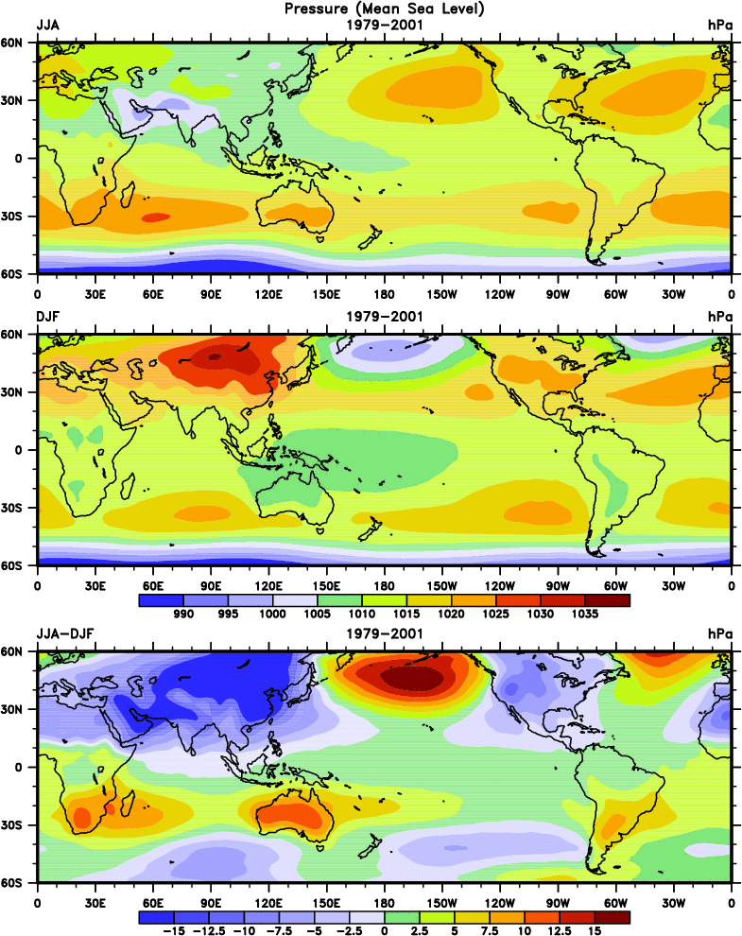

Fig. 3. Sea level pressures for 1979-2001 averaged for JJA (top), DJF (middle) and their difference JJA−DJF (bottom). The contour interval in the top two panels is 5 hPa and 2.5 hPa in the bottom panel.
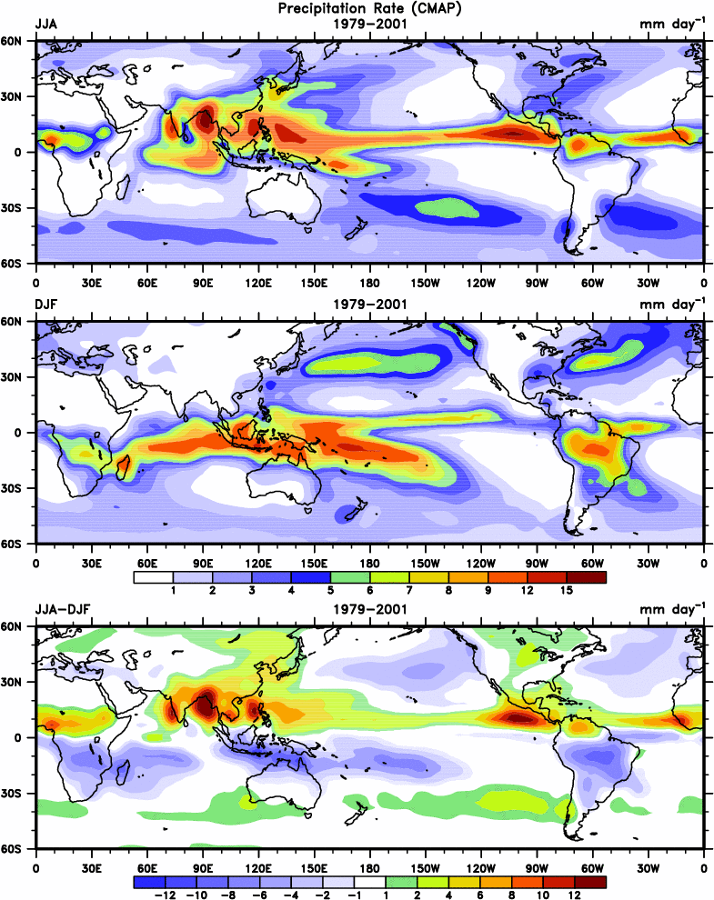
Fig. 4. Precipitation rate (from CMAP) for 1979-2001 averaged for JJA (top), DJF (middle) and their difference JJA−DJF (bottom). The contour interval is in mm day⁻¹.
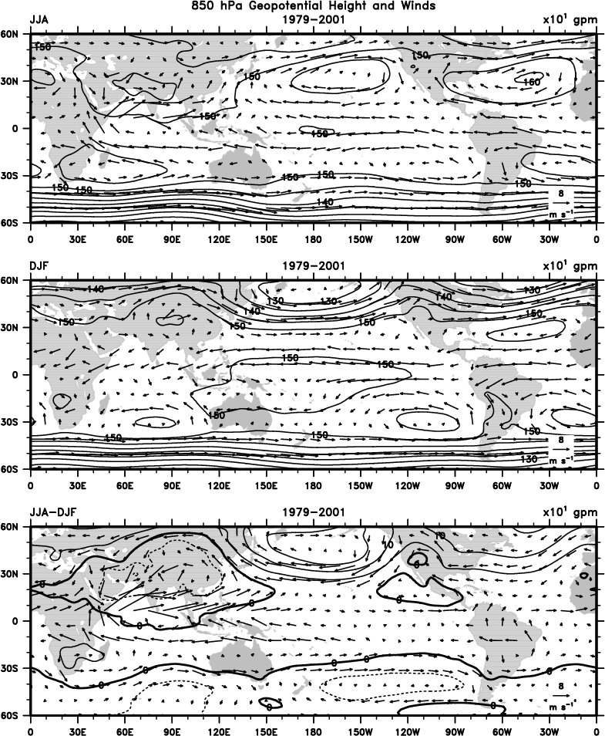

Fig. 5. Geopotential height and vector winds at 850 hPa for 1979-2001 averaged for JJA (top), DJF (middle) and their difference JJA−DJF (bottom). The contour interval is 5 dam and the key vector wind is plotted at lower right corresponding to 8 m s⁻¹.
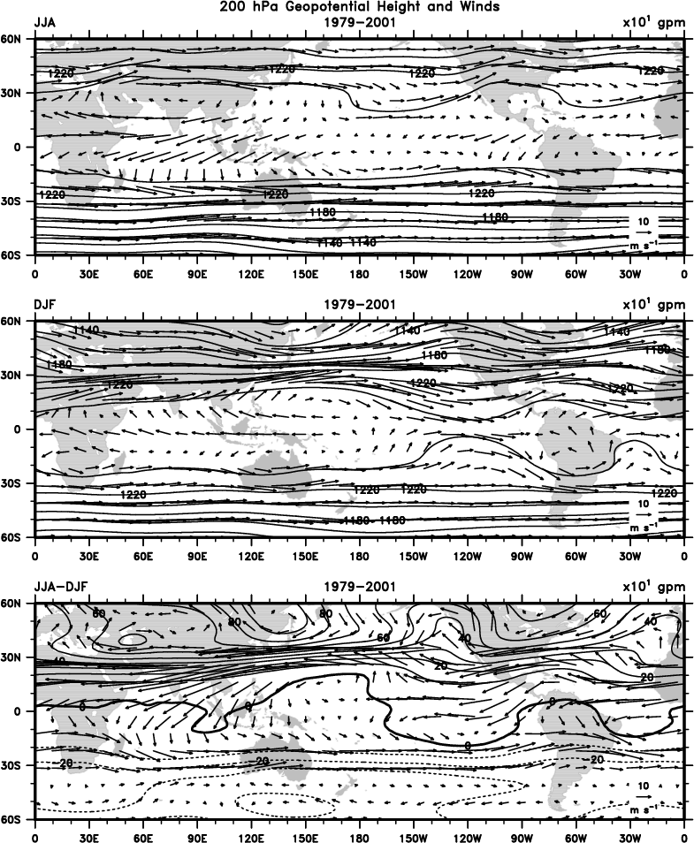

Fig. 6. Geopotential height and vector winds at 200 hPa for 1979-2001 averaged for JJA (top), DJF (middle) and their difference JJA−DJF (bottom). The contour interval is 20 dam and the key vector wind is plotted at lower right corresponding to 10 m s⁻¹.
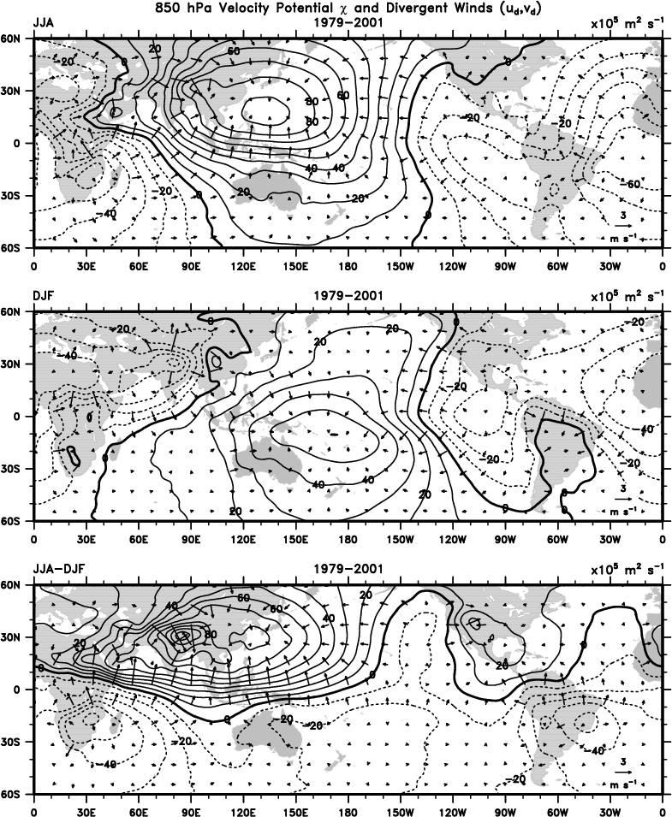

Fig. 7. Velocity potential and divergent component of vector winds at 850 hPa for 1979-2001 averaged for JJA (top), DJF (middle) and their difference JJA−DJF (bottom). The contour interval is 10⁶ m² s⁻¹ and the key vector wind is plotted at lower right corresponding to 3 m s⁻¹.
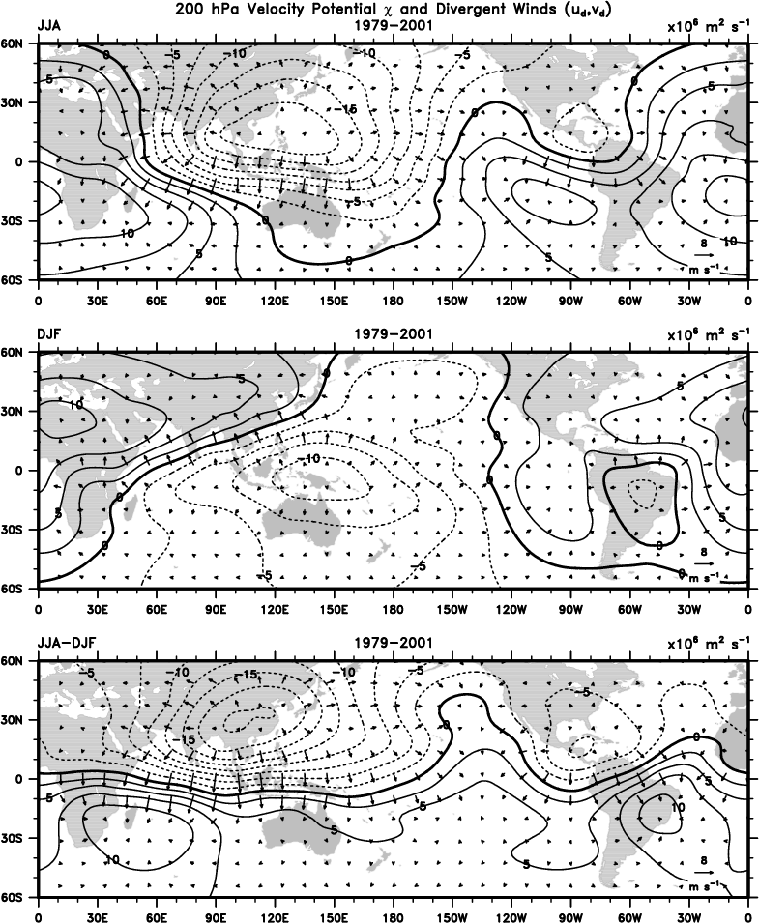

Fig. 8. Velocity potential and divergent component of vector winds at 200 hPa for 1979-2001 averaged for JJA (top), DJF (middle) and their difference JJA−DJF (bottom). The contour interval is 2.5×10⁶ m² s⁻¹ and the key vector wind is plotted at lower right corresponding to 8 m s⁻¹.
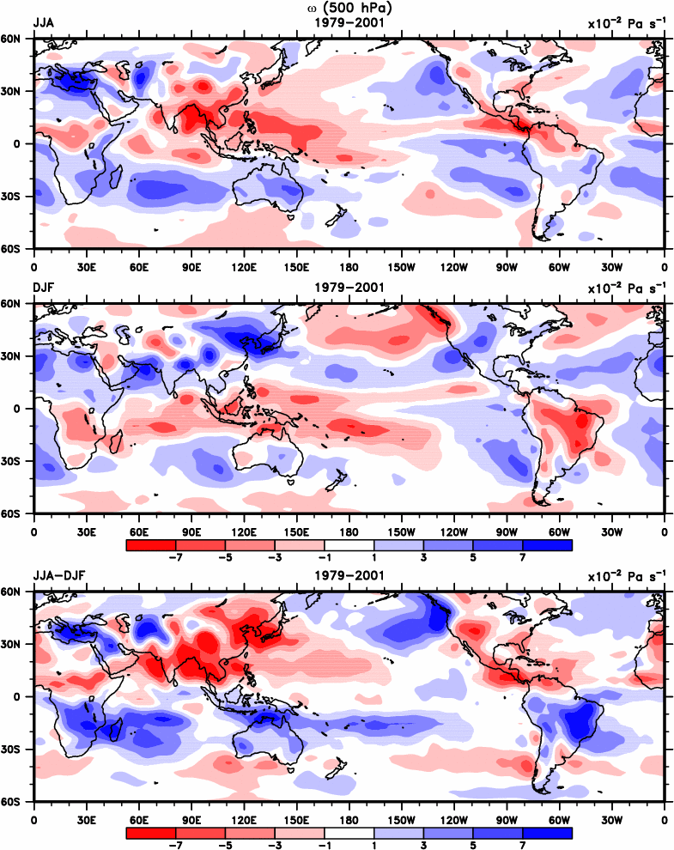
Fig. 9. Vertical p-velocity (ω) at 500 hPa for 1979-2001 averaged for JJA (top), DJF (middle) and their difference JJA−DJF (bottom). The contour interval is 2×10⁻² Pa s⁻¹ .

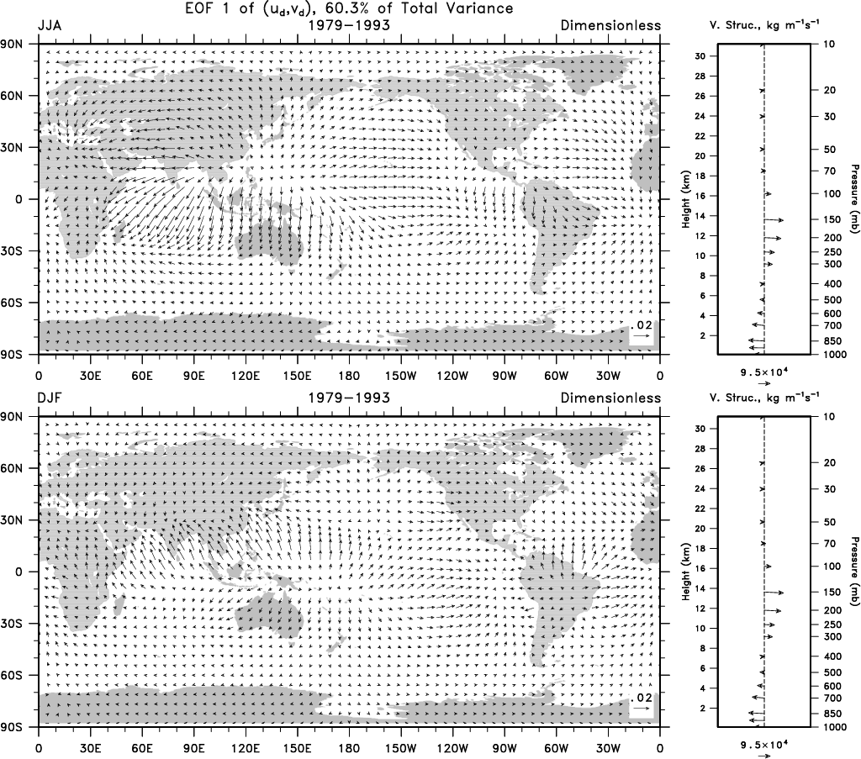
Fig. 10. Spatial patterns of CEOF1, in which all four seasons were combined, for the divergent velocity from NCEP reanalyses for JJA (top) and DJF (below) corresponding to the vertical structure function of the mass weighted divergent velocity field at right for 1979-1993 (Trenberth et al. 2000). The scale vector is given below. The vertical structure vectors are referenced to that at 1000 hPa, which is directed along the x axis; they are free to rotate through 360˚ but tend to be aligned, the scale factor is given below and the units are kg m⁻¹ s⁻¹. The vertical scale is in hPa and with an approximate height scale given.
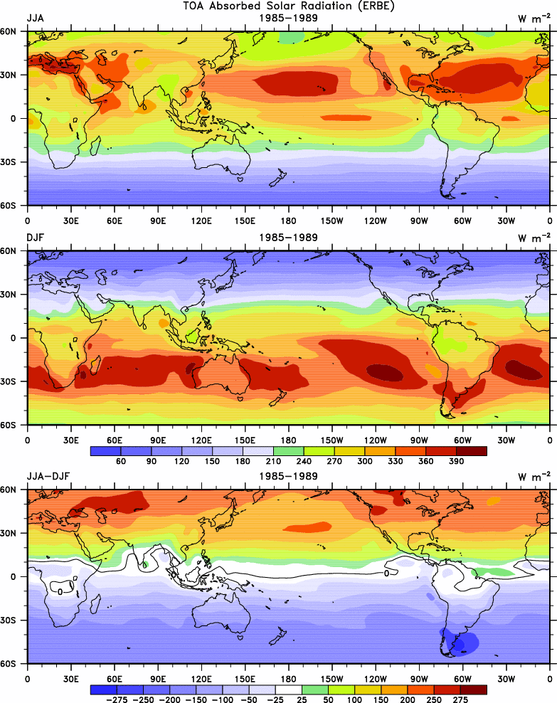

Fig. 11. Absorbed Solar Radiation (ASR) for 1985-1989 averaged for JJA (top), DJF (middle) and their difference JJA−DJF (bottom). The contour interval in the top two panels is 30 W m⁻² and 25 or 50 W m⁻² in the bottom panel with the zero contour in black.

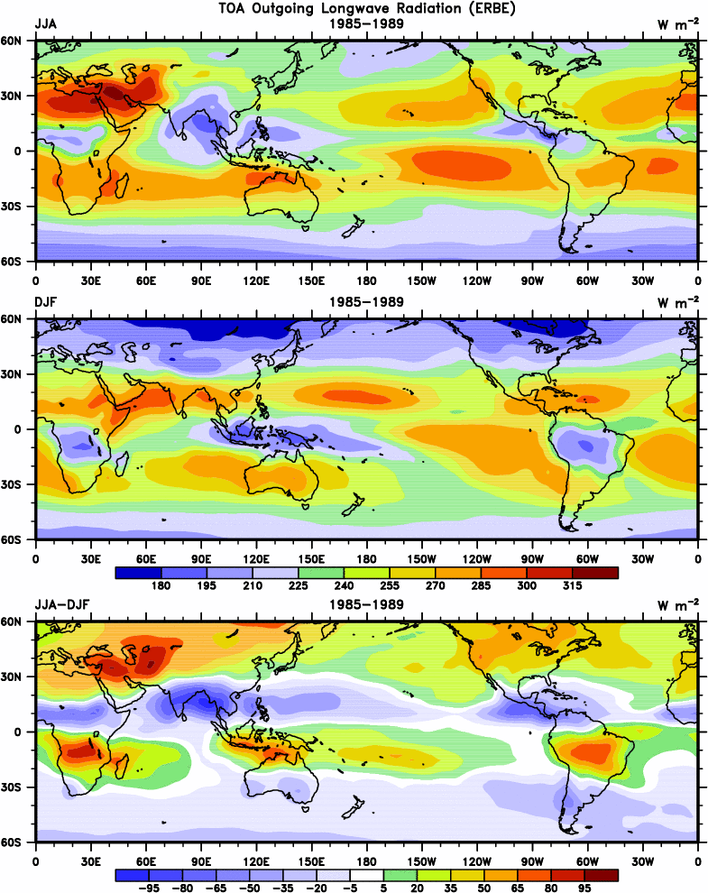
Fig. 12. Outgoing Longwave Radiation (OLR) for 1985-1989 averaged for JJA (top), DJF (middle) and their difference JJA−DJF (bottom). The contour interval is 15 W m⁻².

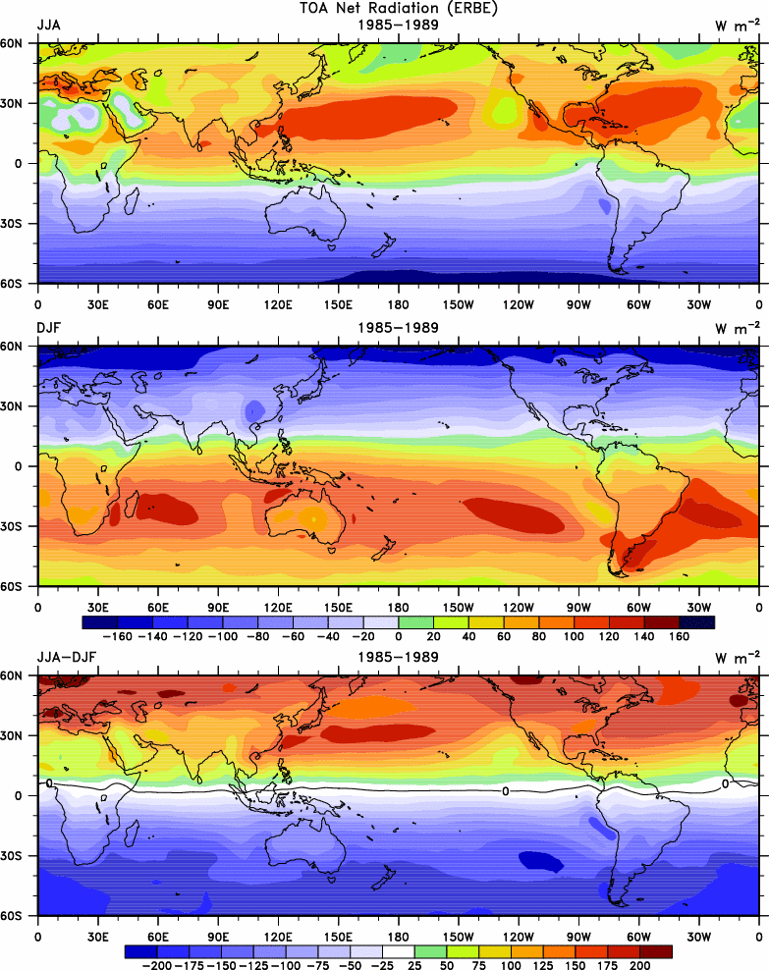
Fig. 13. Net radiation for 1985-1989 averaged for JJA (top), DJF (middle) and their difference JJA−DJF (bottom). The contour interval in the top two panels is 20 W m⁻² and 25 W m⁻² in the bottom panel with the zero contour in black.

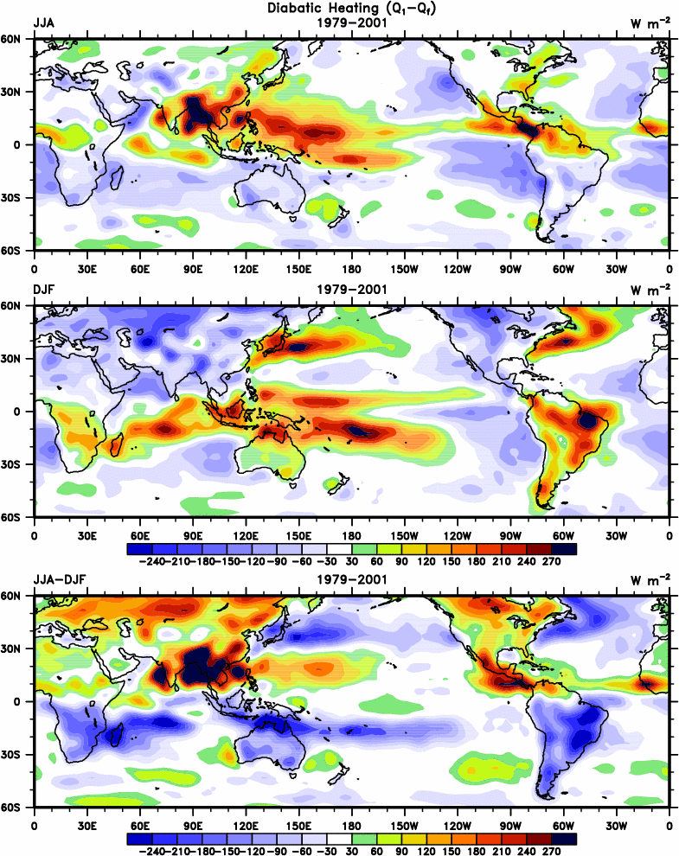

Fig. 14. Vertically integrated atmospheric diabatic heating for 1979-2001 averaged for JJA (top), DJF (middle) and their difference JJA−DJF (bottom). The contour interval is 30 W m⁻².

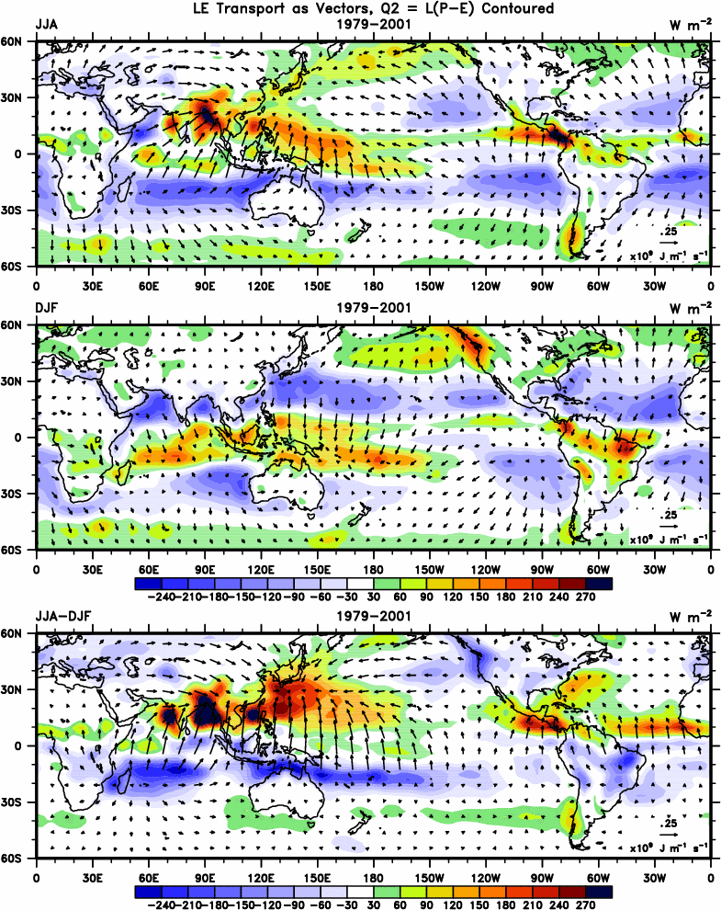

Fig. 15. Vertically integrated atmospheric latent heating L(P−E) for 1979-2001 averaged for JJA (top), DJF (middle) and their difference JJA−DJF (bottom). Also plotted is the divergent component of the latent energy transports as vectors, key at lower right, in 10⁹ W m⁻¹. The contour interval in the top two panels is 30 W m⁻².
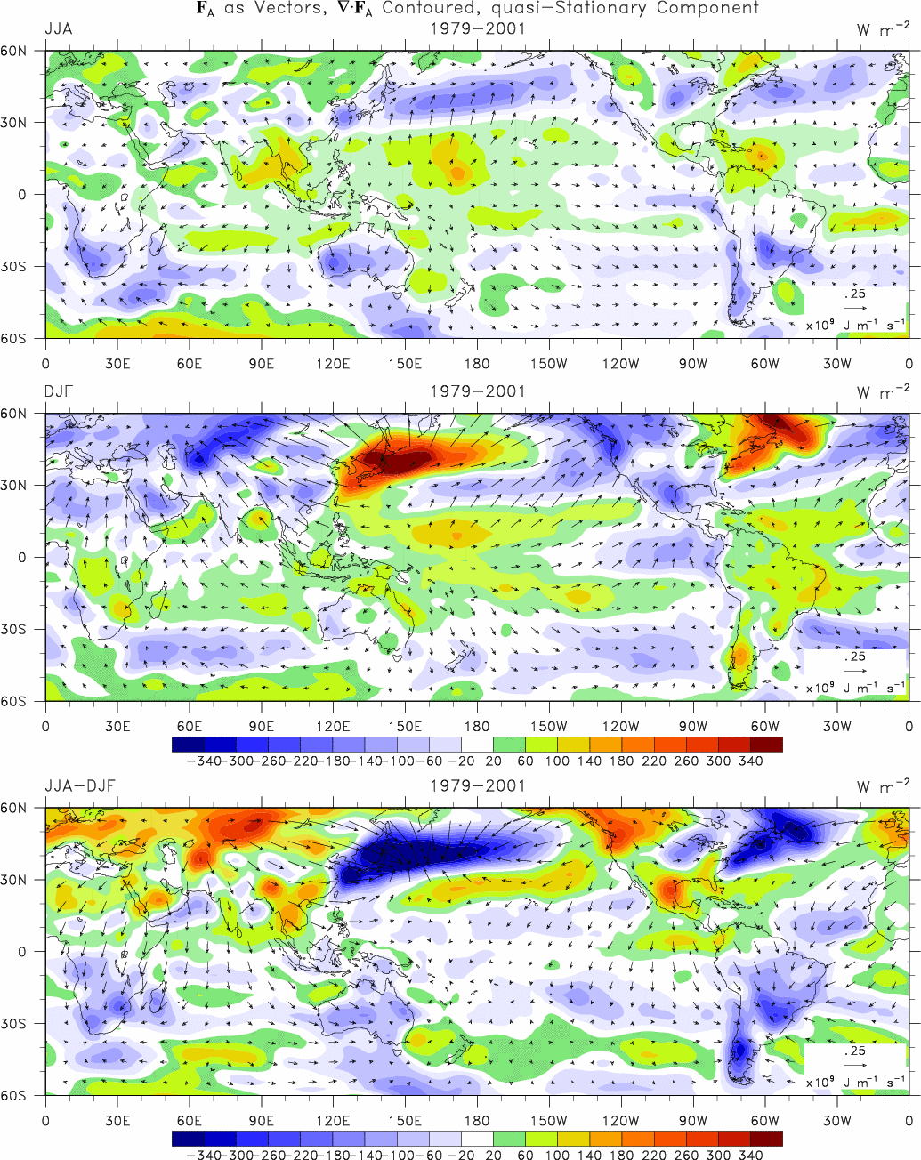

Fig. 16. Divergence of and divergent component of vectors of the vertically-integrated total atmospheric energy transports for 1979−2001 averaged for JJA (top), DJF (middle) and their difference JJA−DJF (bottom). The first set of panels show the component from the quasi-stationary flow (monthly means and longer) and second set of panels show the transient flow contributions. The contour interval is 20 W m⁻².

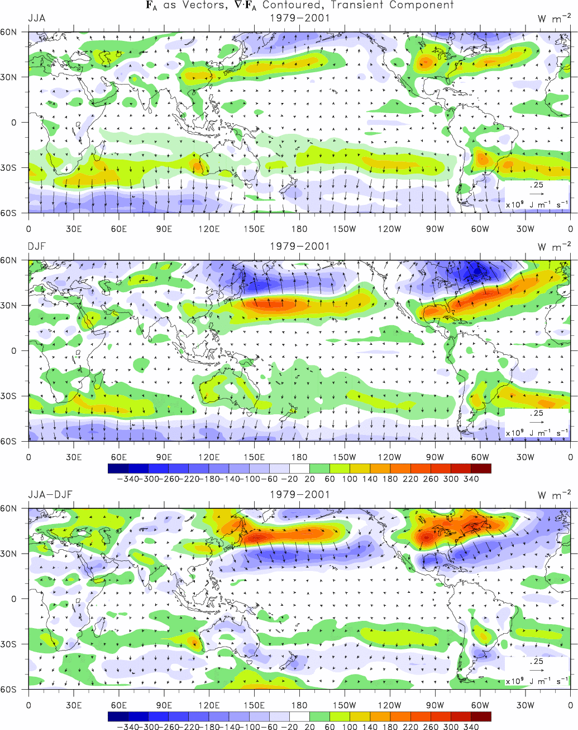
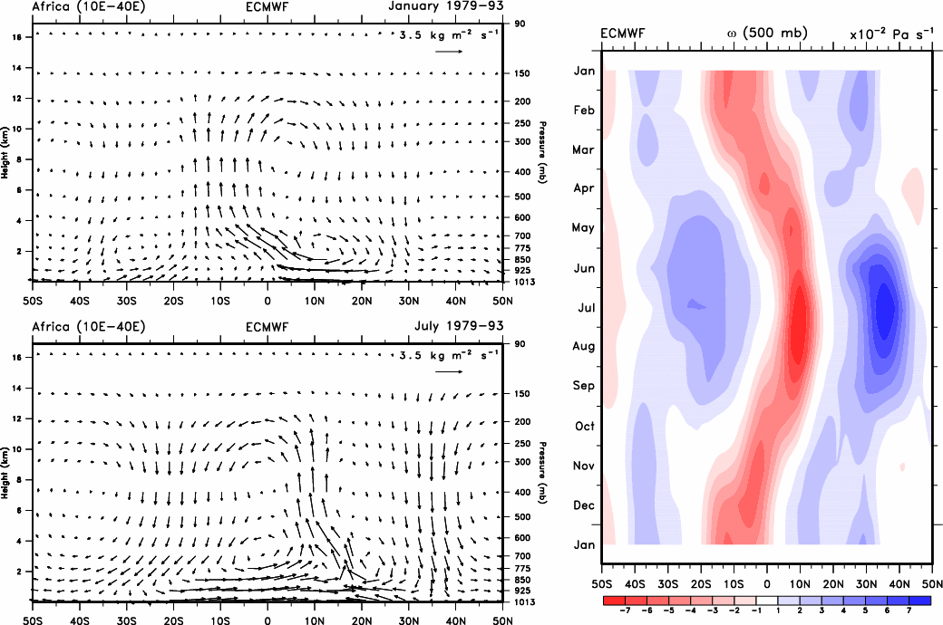

Fig. 17. For Africa. Regional meridional cross sections of the divergent flow as vectors from 50˚S to 50˚N from ECMWF for January (top) and July (bottom). The scale vector is top right. At right is shown the annual cycle of ω at 500 hPa from 50°S to 50°N in 10⁻² Pa s⁻¹. Red indicates upward motion and blue subsidence. Adapted from Trenberth et al. (2000).

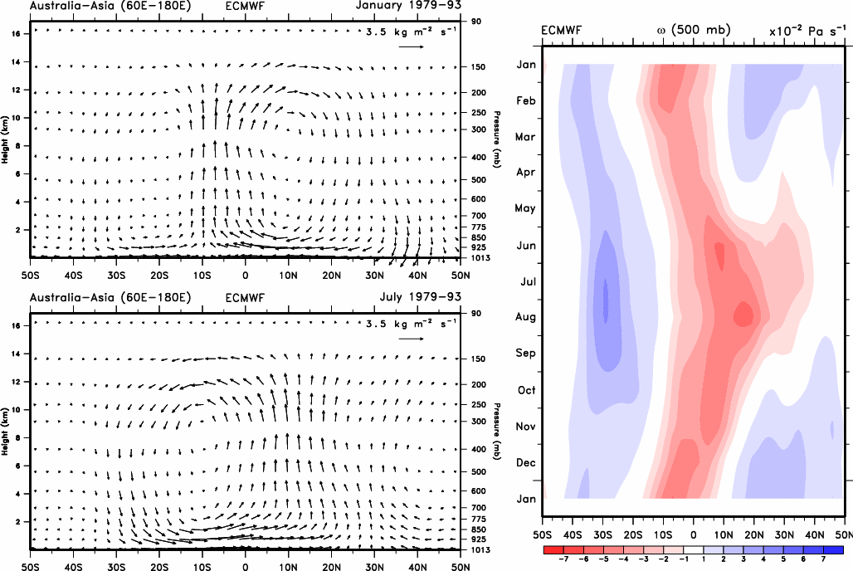

Fig. 18. For Australia-Asia. Regional meridional cross sections of the divergent flow as vectors from 50°S to 50°N from ECMWF for January (top) and July (bottom). The scale vector is top right. At right is shown the annual cycle of ω at 500 hPa from 50˚S to 50˚N in 10⁻² Pa s⁻¹. Red indicates upward motion and blue subsidence. Adapted from Trenberth et al. (2000).

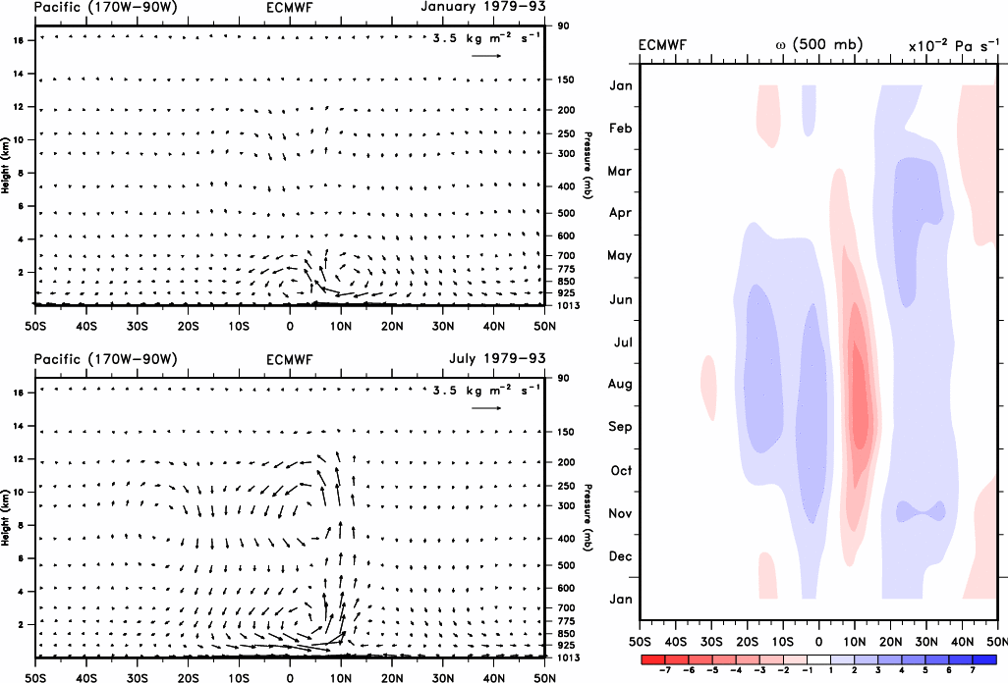

Fig. 19. For the Pacific. Regional meridional cross sections of the divergent flow as vectors from 50°S to 50°N from ECMWF for January (top) and July (bottom). The scale vector is top right. At right is shown the annual cycle of ω at 500 hPa from 50˚S to 50˚N in 10⁻² Pa s⁻¹. Red indicates upward motion and blue subsidence. Adapted from Trenberth et al. (2000).

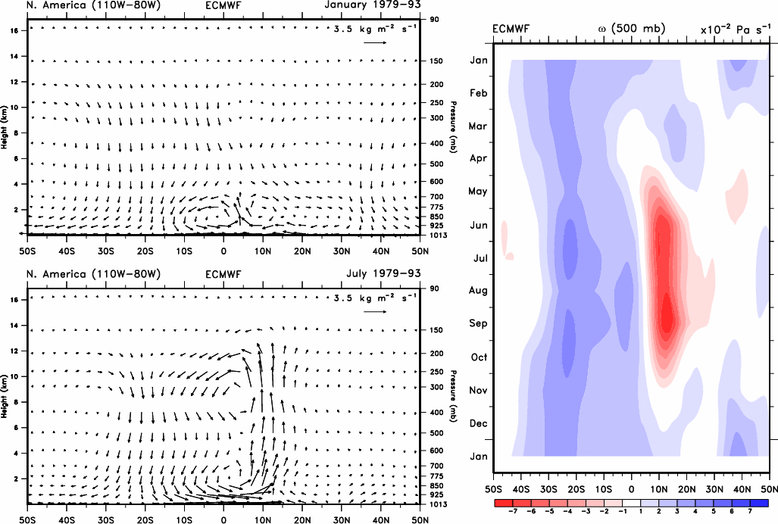

Fig. 20. For North America. Regional meridional cross sections of the divergent flow as vectors from 50°S to 50°N from ECMWF for January (top) and July (bottom). The scale vector is top right. At right is shown the annual cycle of ω at 500 hPa from 50˚S to 50˚N in 10⁻² Pa s⁻¹. Red indicates upward motion and blue subsidence. Adapted from Trenberth et al. (2000).

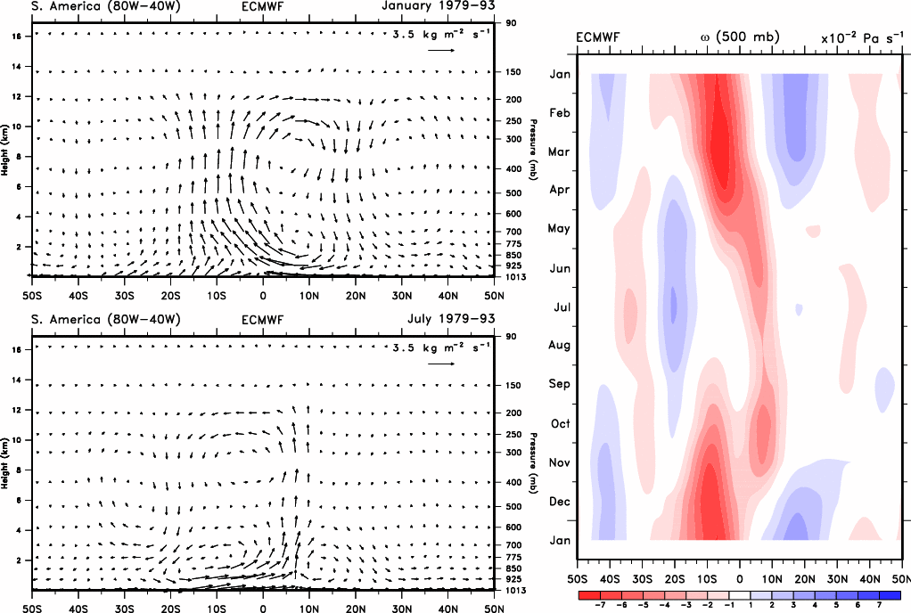

Fig. 21. For South America. Regional meridional cross sections of the divergent flow as vectors from 50°S to 50°N from ECMWF for January (top) and July (bottom). The scale vector is top right. At right is shown the annual cycle of ω at 500 hPa from 50˚S to 50˚N in 10⁻² Pa s⁻¹. Red indicates upward motion and blue subsidence. Adapted from Trenberth et al. (2000).

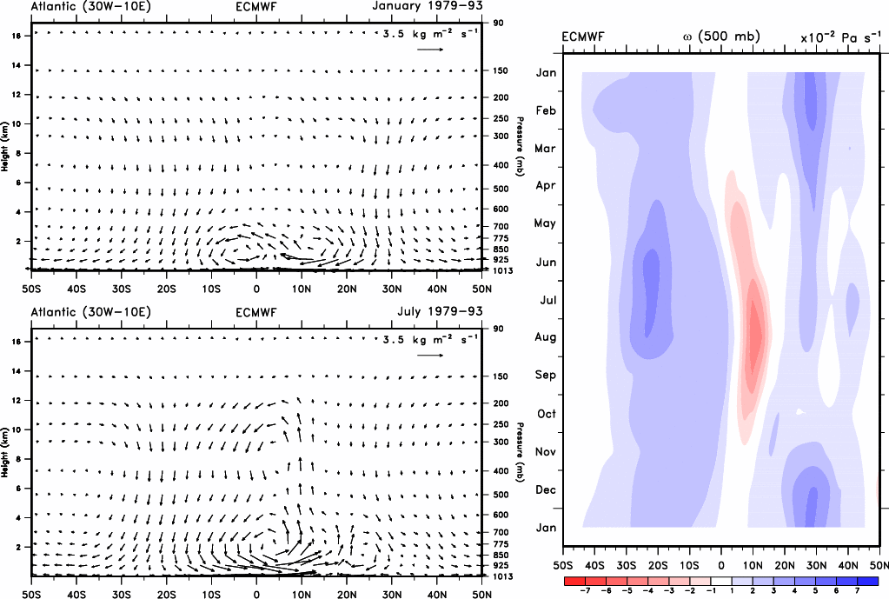

Fig. 22. For the Atlantic. Regional meridional cross sections of the divergent flow as vectors from 50°S to 50°N from ECMWF for January (top) and July (bottom). The scale vector is top right. At right is shown the annual cycle of ω at 500 hPa from 50˚S to 50˚N in 10⁻² Pa s⁻¹. Red indicates upward motion and blue subsidence. Adapted from Trenberth et al. (2000).

The National Center for Atmospheric Research is sponsored by the National Science Foundation.

